Software Requirement Specification Document

For

Project Title:- Complaint Management System

Table of Contents
Page Number
- Introduction 3
  - Purpose 3
  - Intended Customers/Users 3
  - Product Scope 4
  - Outline of the document 4
- Overall Description 5
  - Product Perspective 5
  - Product Functions 5
  - User Classes 5
  - Design and Implementation Constraints 6
- Diagrams 9
  - UML Diagrams 9
  - ER Diagrams 35
  - DFD Diagrams 36
- External Interface Requirements/Screenshots 38
  - User Interfaces 38
  - Hardware Interfaces 38
  - Software Interfaces 39
  - Communication Interfaces 39
- Other Non-Functional Requirements 40
  - Performance Requirements 40
  - Safety Requirements 40
  - Security Requirements 41
  - Software Quality Attributes 41
  - Business Policies/Rules (if any) 41
- Testing 42
  - White-Box Testing 42
  - Black-Box Testing 47
- Conclusion 63
- References 63
- Acknowledgements 63

- Introduction:-

- The Complaint Management System is an application that was created with the intention of offering a proper and organized way for the complainants to complain and for the complaints to be followed up and sorted.
- The fact is that in various institutions and organizations, the process of complaint management is done manually, and the end results are usually delays, misunderstanding, and improper recording of the complaints. The proposed system is therefore expected to mitigate such challenges.

1.1Purpose:-

- The aim of this project is to create a Complaint Management System where users can submit complaints and track them.
- Many companies process complaints manually, which is inefficient.
- The system assists in the reduction of paperwork and human effort associated with complaints through automation.
- It offers a common platform for complaint registration, reporting, and resolution.
- The system ensures transparency in that it allows complainants to see the status of their complaints.
- Administrator control is also added in order to handle the complaints.
- This document of the SRS describes the functionality of the system, its functionality, limitations, and user interface.

1.2 Intended Customers/Users:-

- Students: They can utilize the system to lodge grievances regarding academic matters, infrastructural aspects, or campus services.
- Employees: They can provide information on workplace and administrative matters.
- Customers – Customers of an organization can file complaints regarding services.
- Administrators – These are responsible for handling complaints, verifying information, and changing the complaint status.
- Management – Management officials are able to track complaint resolution cases and reports.
- Support Staff - Support staff are able to resolve complaintsallocated to them.

1.3Product Scope:-

- The Complaint Management System can be developed by building a centralized digital platform.
- The users are able to create complaints with appropriate details like category and description.
- This is because it enables users to be aware of the status of their complaints.
- Administrators can view, handle, and resolve complaints effectively.
- All complaints are stored in a database for future references.
- The system promotes communication between the user and the authority.
- The last software decreases manual efforts and increases overall efficiency in servicing

1.4Outline of the document:-

- Introduction:-

- This chapter will introduce the Complaint Management System.
- Defines the purpose, target audience, product, and document structure.

- Overall Description:-

- The chapter explains how the system functions as a whole.
- It contains the product view, system functions, user categories, and constraints.

2. Overall Description:-

- All the above sections elaborate on the working environment in the Complaint Management System, the main functionality of the system, the types of users, as well as the limitations within which the system works.
- They offer a general idea about the operation of the system within an organization.

2.1 Product Perspective:-

- The Complaint Management System functions in the following environment:
- It is an independent application solely used for complaint resolution.
- It can also be incorporated as a module in a larger organizational framework.
- The system has interactions with the central database for storing and retrieving the complaint information.
- It could be linked to established institutional databases for verification purposes.
- The system operates in an online platform and needs internet connectivity.
- It can be accessed using a web browser or a desktop client.
- The system enables communication between the users and the administrators through a central platform.

2.2 Product Functions:-

- The Complaint Management System functions in the following environment:
- It is an independent application solely used for complaint resolution.
- It can also be incorporated as a module in a larger organizational framework.
- The system has interactions with the central database for storing and retrieving the complaint information.
- It could be linked to established institutional databases for verification purposes.
- The system operates in an online platform and needs internet connectivity.
- It can be accessed using a web browser or a desktop client.
- The system enables communication between the users and the administrators through a central platform.

2.3 User Classes:-

- The system has the capability to support various classes of users with different levels of access.
- Student / Customer:-
- Has the ability to register and log into the system.
- Can submit new complaints.
- Can track the status of submitted complaints.
- Support Staff:-
- Can see the grievances assigned to it.
- Can update details of progress or resolution.
- Administrator:-
- Has the complete control over the system.
- Can view all complaints.
- Can assign complaints to support staff.
- Can generate reports and manage users.
- Each type of user has access based on roles.
- Unauthorized use of system services is prevented.

2.4 Design and Implementation Constraints:-

- The Complaint Management System also has some limitations regarding hardware, software, network, database, browser compatibility, and security.
- The aforementioned factors should also be kept in mind while implementing this system for hassle-free functionality.

- Hardware Limits:-

- The system will need a computer or a mobile device to run the application.
- Systems with low memory or slower processing speeds can lead to slow response times.
- The hardware of the server determines the number of users who can access the system at a particular time.
- The storage capacity determines the number of complaints that one can hold.
      - There may be a temporary loss of functionality when it comes to lodging grievances due to hardware failure
      - Depending on the hosting server, the performance can vary.

- Software Requirements:-

- It also requires a supported operating system such as Windows or Linux.
- A web browser needs to be modern in order to access the Complaint Management System.
- The installation of the backend software like Java Runtime Environment is required.
- The database software must be able to store the details of the complaint safely.
- Incompatible versions of software can lead to errors in the system.
- It requires frequent software updatein order to achieve stability.

- Regulatory Rules:-

- The system will have to abide by the privacy policy guidelines while dealing with user information.
- Personal information of the users should not be shared without consent.
- The records of the complaint must be kept within organizational requirements.
- The complaint data can only be accessed based on the roles of the users.
- The rules regarding data retention also need to be followed for old files related to complaints.
- System activity should be recorded in a log.

- Network Dependency:-

- The Complaint Management System requires internet connectivity.
- Failure of the network could hinder users from posting or viewing complaints.
- A low bandwidth can cause a delay in system response time.
- When the server goes offline, this could make the system momentarily unvailable.
- In order for the transmission of data to occur in a secure and safe manner, a secure
- Users are totally dependent on network availability.
- Database Size Constraints

- Database Size:-

- The database has limited storage capacity.
- A large number of complaints may degrade database performance.
- Old complaints could have to be archived in order to conserve storage space.
- Database backup consumes extra memory resources.
- Lack of proper management of the database can cause inconsistency in the data.
- The expansion of the database can also be necessary due to the increase in complaint data.

- Security Constraints:-

- Secure login is required for all who use this system.
- Poor passwords could cause unauthorized access.
- Only those authorized must view the complaint information.
- Sensitive data must be encrypted in order to prevent misuse.
- The security breaches can also impact system reliability.
- It is essential that the system be regularly checked for security.

3.Diagrams:-

3.1 UML Diagrams

a)Use Case Diagrams:-

- User Management Module:-

- Module Description:-

- It is responsible for all kinds of user types in the system.
- Users are able to register, sign in, and manage their profiles here.
- With their preferred choice of role (Student, Staff, or Admin), they are able to access certain features.
- This module promotes safe and efficient system access.

- Primary Actor:-

- User (Student/Staff/Admin)
- The major role player is the user, who actually engages with the system to create a registration, login, or manage a personal account.

- Secondary Actor:-

- System Database
- The database will store information such as the username, password, role, and user profile.

- Use Case Diagram Description:-

- In the use case diagram, the User actor is linked to use cases such as Register User, Login, Logout, Select Role, and Manage Profile.
- These use cases are all within the system boundary to indicate that they are part of the system.

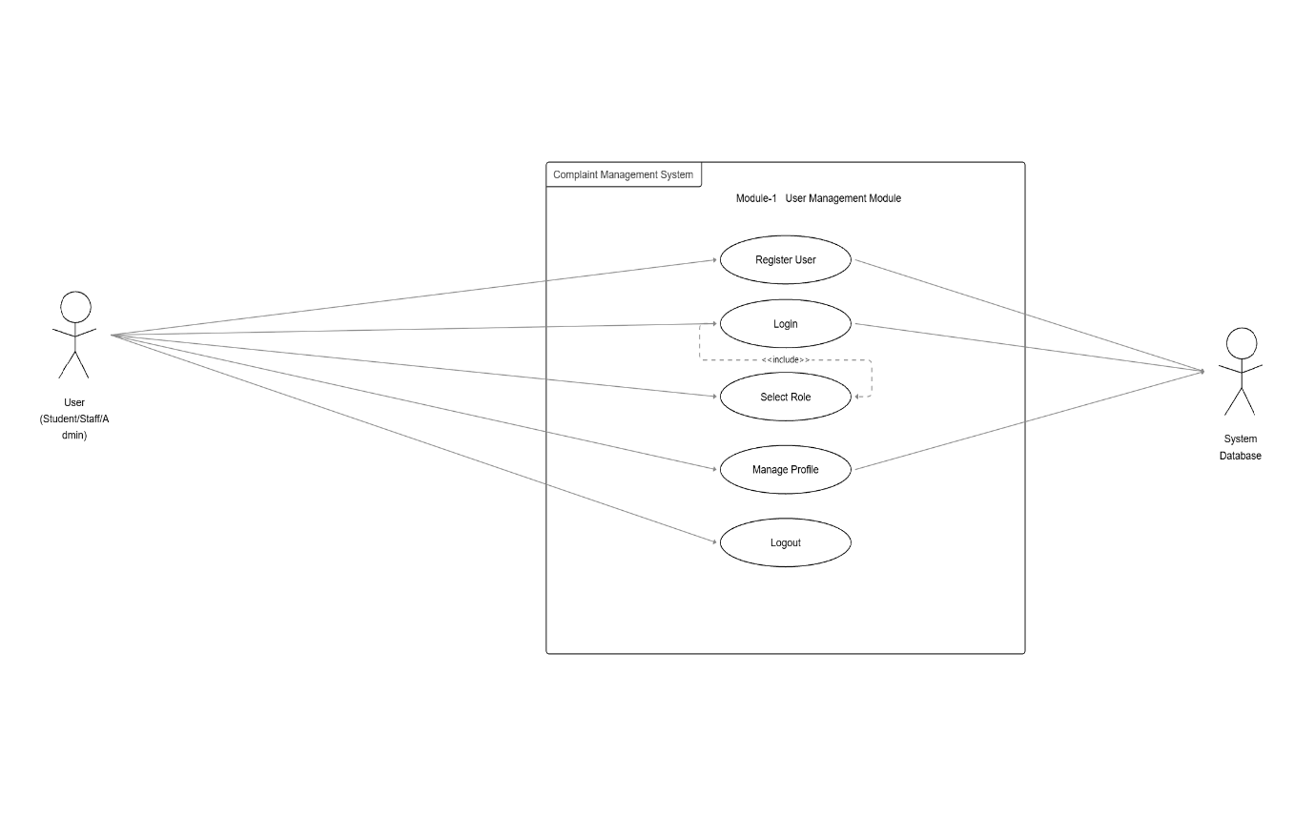
- Complaint Registration Module:-

- Module Description:-

- This module is used by the user to complain about different departments.
- He can input complaint title, description, select the department, and if any proof, then attach it.
- After submission, it will automatically generate a complaint ID from the system.

- Primary Actor:-

- Student / Staff.
- They file complaints by filling out necessary information.

- Secondary Actor:-

- System.
- The system generates the complaint ID and stores the complaint details.

- USE CASE DIAGRAM DESCRIPTION :-

- The use cases associated with the actor Student or Staff are Register Complaint, Select Department, Upload Proof, and Generate Complaint ID.
- These interactions show how users submit complaints.
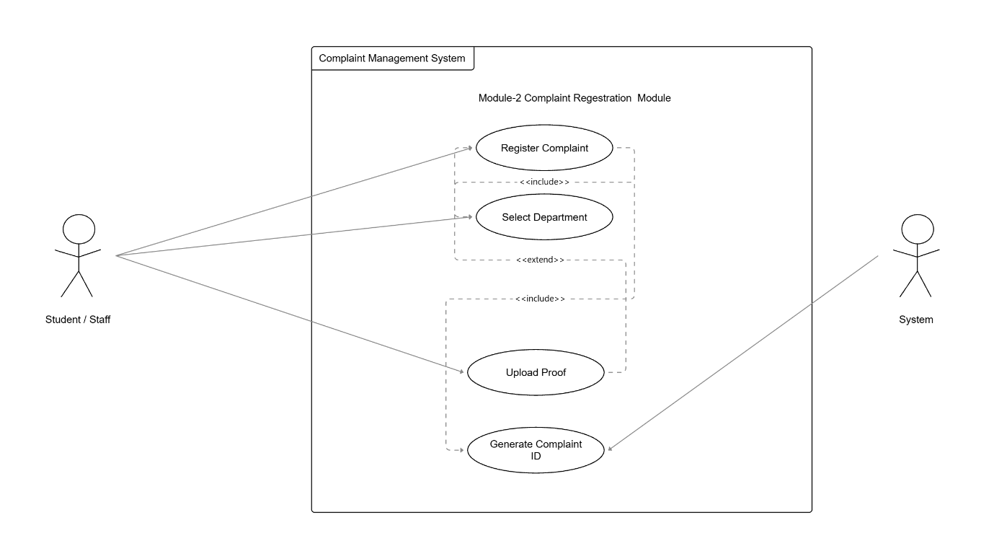

3. Complaint Tracking Module:-

- Module Description:-

- This module will help users trace the progress of their complaints.
- The user is then able to view the status that is pending, in progress, or resolved.
- It also shows complaint history with date and time.

- Primary Actor:-

- Student / Employee
- They verify the status of their complaints submitted.

- Secondary Actor:-

- System.
- Complaint status & history are fetched from the database by this system.

- Use Case Diagram Description:-

- This actor can be related to use cases such as View Complaint Status, View Complaint History, and Track Date & Time, showing how users monitor their complaints.

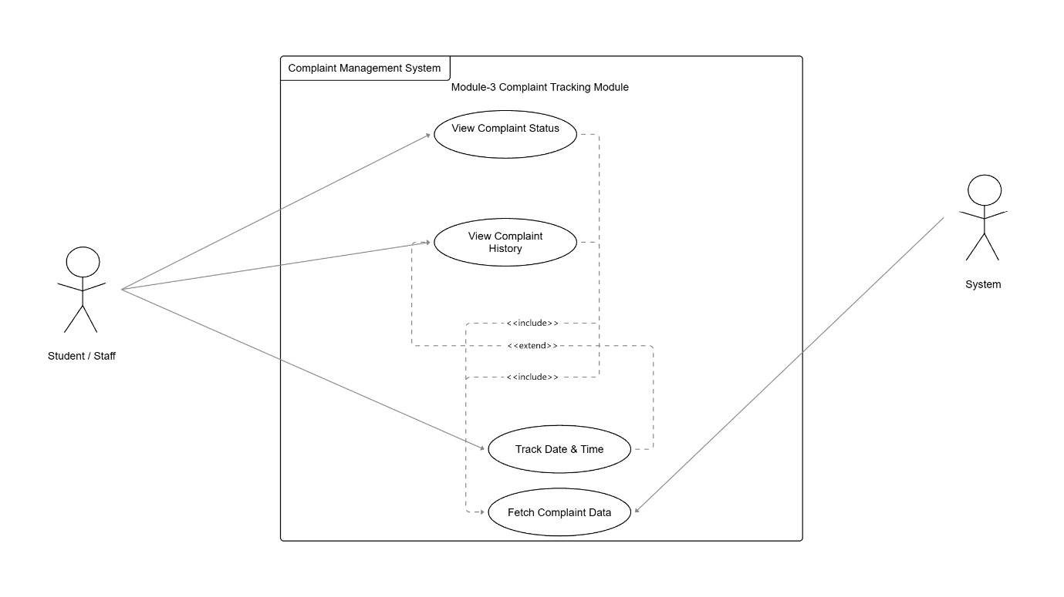
4.Department Handling Module:-

- Module Description:-

- This module is utilized by staff members coming from various departments.
- Staff members can access complaints they are supposed to handle.
- They are also capable of changing the status of a complaint.
- Finally, they are able to provide solutions or comments when they close a complaint.

- Primary Actor:-

- Department Staff
- They attend to and resolve complaints.

- Secondary Actor:-

- System.
- The Complaint Status is updated, along with the remarks of staff.

- Use Case Diagram Description:-

- The Staff actor will interact with the use cases View Assigned Complaints, Update Status, and Add Solution.
- This will depict the handling of the complaints by the departments
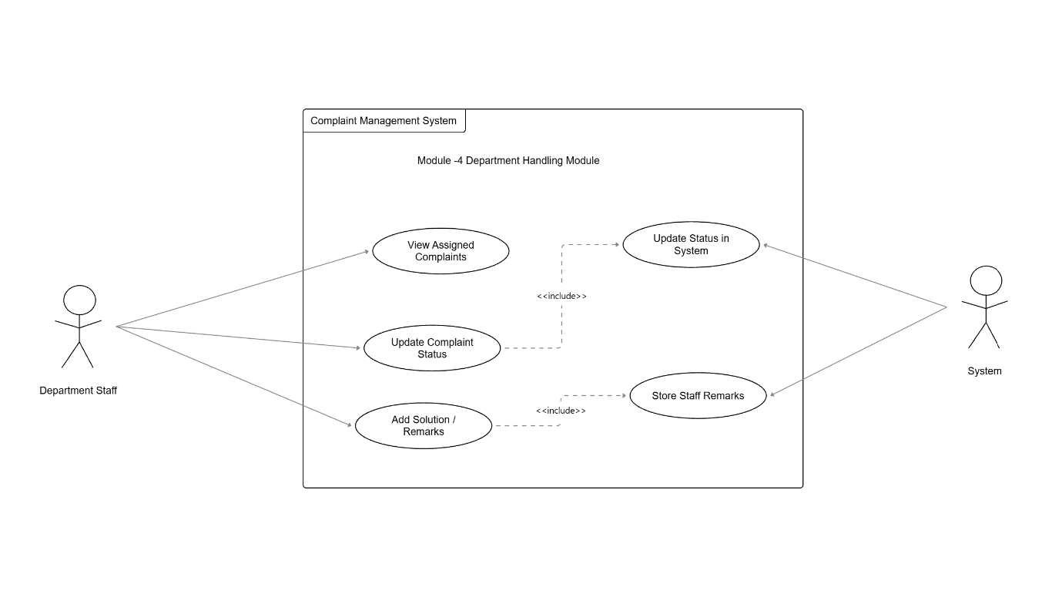
5. Admin Module:-

- Module Description:-

- The Admin Module provides complete control over the system to the admin.
- The admin has the capability to add or remove departments, staff, complaints, and generate reports.

- Primary Actor:-

- Admin.
- Admin is the one who controls the whole system.

- Secondary Actor:-

- Database.
- Stores departments, staff information, complaints, and reports.

- Use Case Diagram Description:-

- Admin Actor is related to use cases such as Add Department, Add Staff, Assign Complaint, and Generate Reports.
- It is related to administrative control.
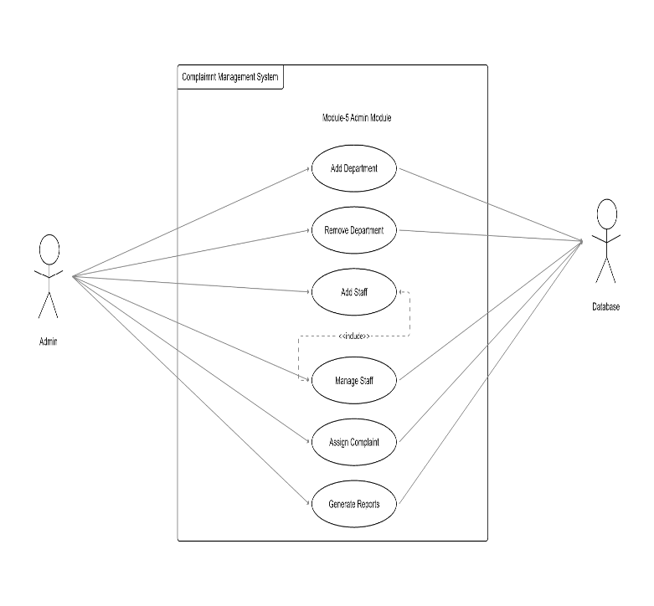
6.Notification Module:-

- Module Description:-

- This module alerts the customer whenever there is a change in the status of the complaint registered by them.
- These alerts may be done by means of emails or text messages, mostly in the event of a complaint being solved.

- Primary Actor:-

- System.
- Automatically sends notifications.

- Secondary Actor:-

- User (Student / Staff)
- Receives notifications.

- Use Case Diagram Description:-

- It is related to the Send Notification use case that is connected to its System.
- It exhibits the communication process between the system and user.
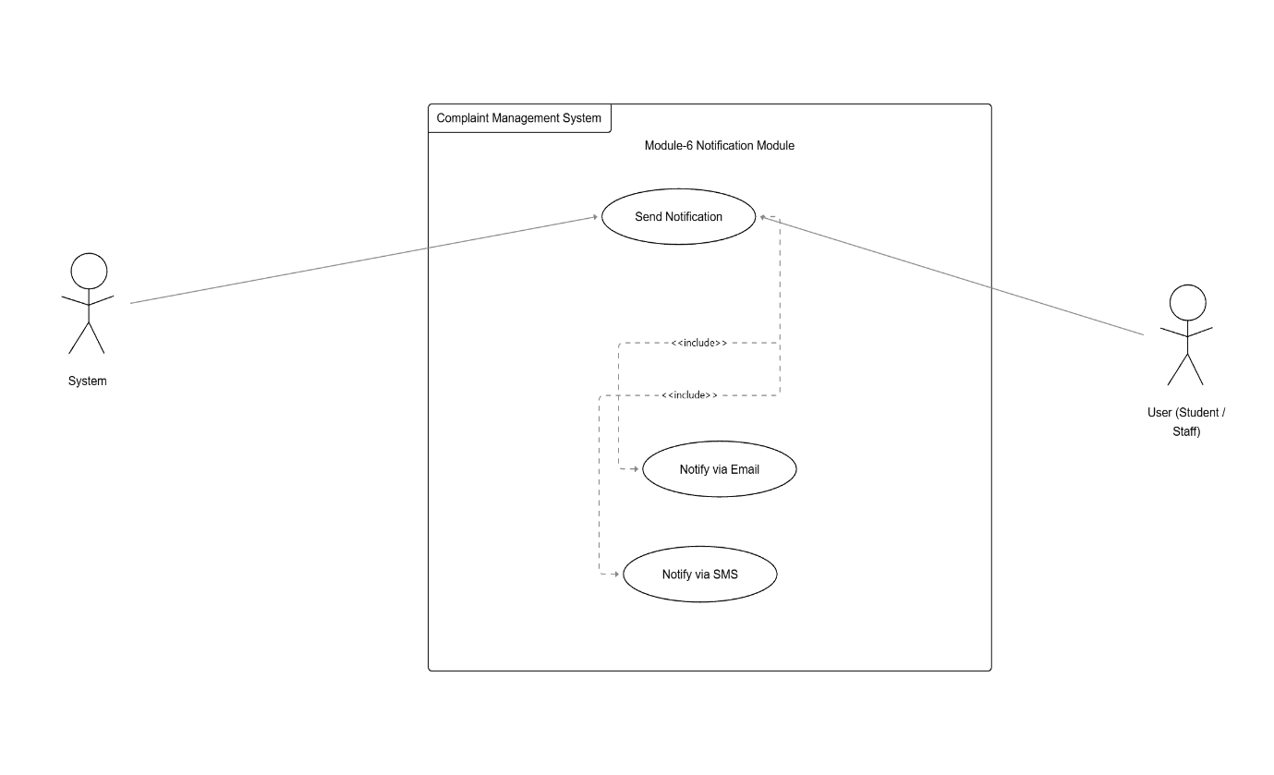

7. Report & Analytics Module:-

- Module Description:-

- This module assists the admin in the analysis of complaint information.
- Reports such as the total number of complaints, the number of complaints pending/resolved, as well as the number of complaints for each department, can be produced.

- Primary Actor:-

- Admin.
- Examines and interprets opinions.

- Secondary Actor:-

- System Database.
- Enables the generation of reports.

- Use Case Diagram Description:-

- Admin is an actor associated with View Reports, Generate Statistics, Department-Wise Analysis.

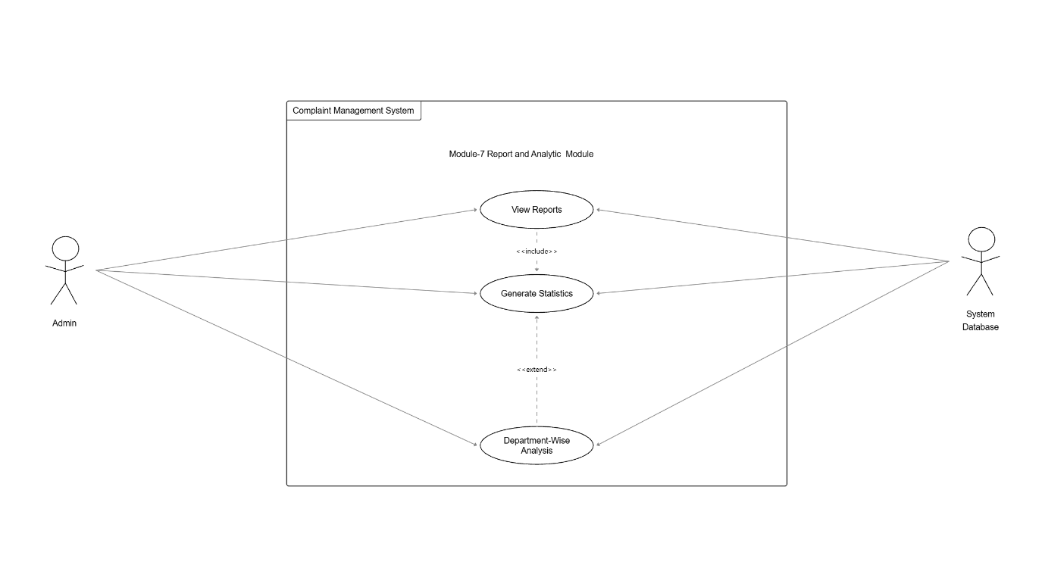

b) Class Diagram:-

1. User Management Module:-

- Description:-

      - All users in the complaint management system are managed through the User Management Module.
      - It facilitates users' registration, login, and upkeep of their individual profile information.
      - System access is controlled by various roles, such as staff, admin, and students.
      - To monitor user activity and guarantee security, login sessions are kept up to date.

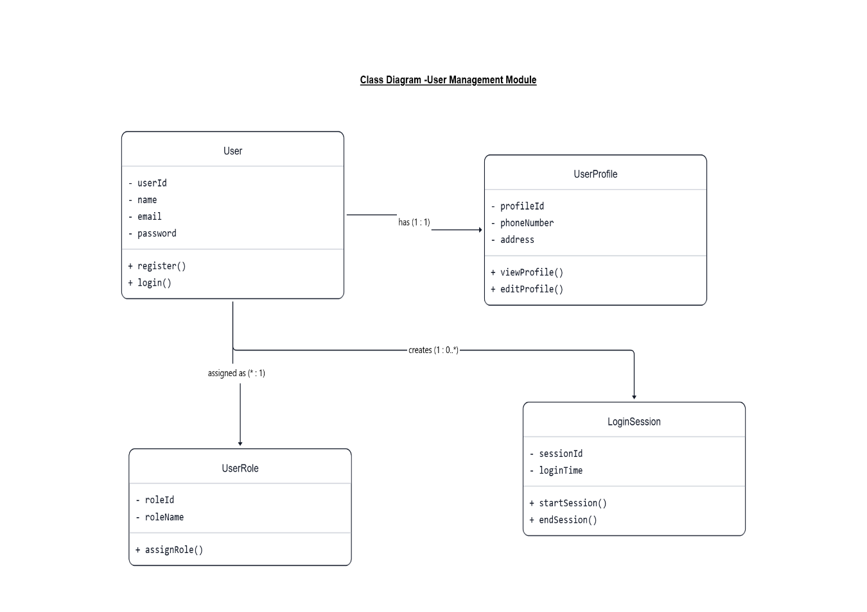

2. Complaint Registration Module:-

- Description:-

- The system's Complaint Registration Module makes it simple for users to file complaints.
- Details about the complaint, including the title, description, date, and attachments, are stored there.
- For appropriate handling, complaints are categorized according to their type and priority level.
- This module makes sure that every complaint is noted and safely kept in the database.

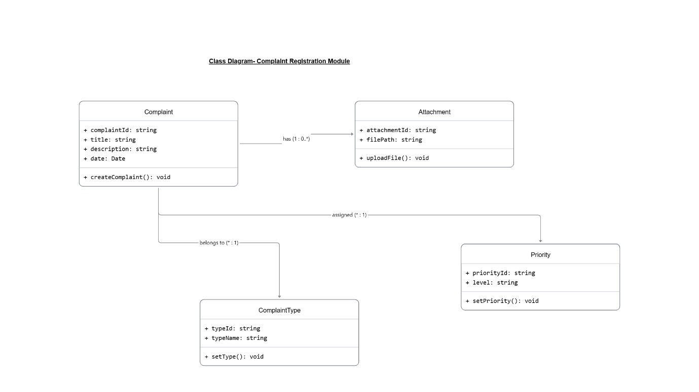

3. Complaint Tracking Module:-

- Description:-

- The status of complaints that have been filed is tracked using the Complaint Tracking Module.
- It maintains a record of every complaint's status updates.
- After their complaint has been addressed, users can provide feedback.
- If complaints are not resolved promptly, they may be forwarded to higher authorities.
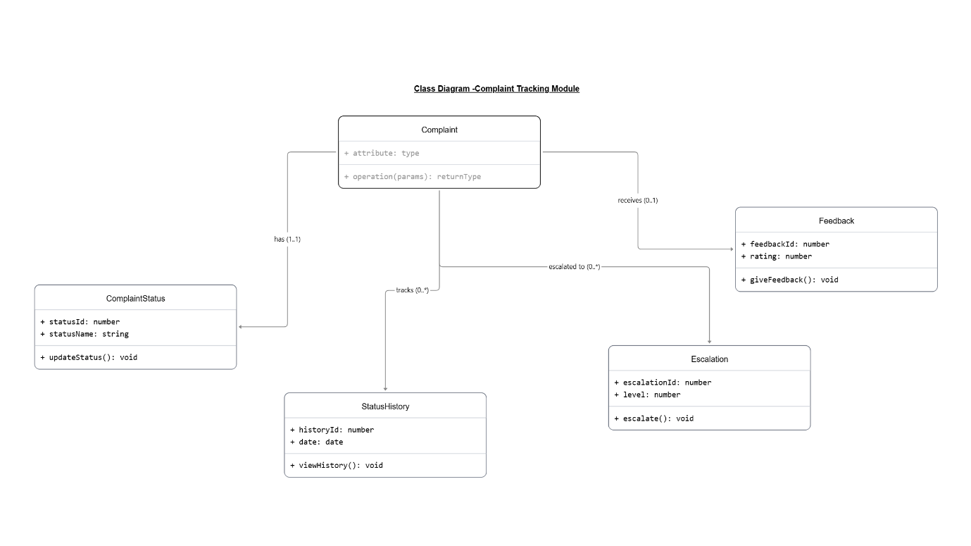

4. Department Handling Module:-

- Description:-

- Complaints are assigned to the appropriate departments by the Department Handling Module.
- It oversees employees who work in various departments.
- Employees offer solutions, and the system records the specifics of those solutions.
- This module is used to manage staff shifts and work schedules.

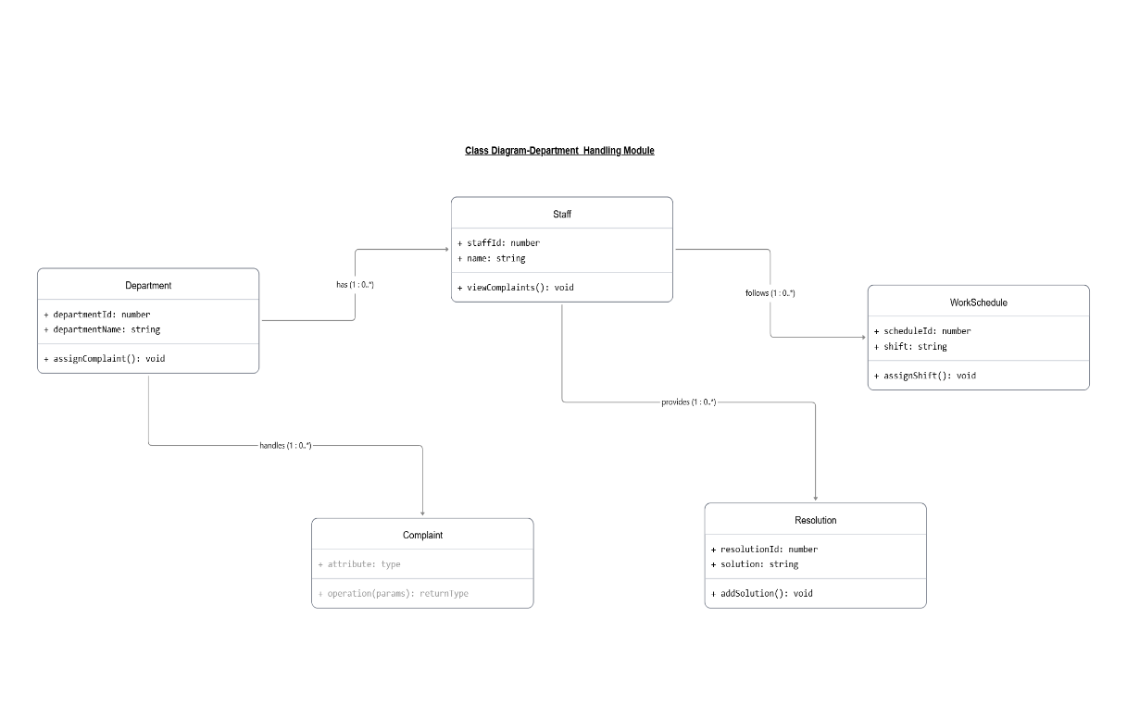

5. Admin Module:-

- Description:-

- Administrators use the Admin Module to oversee and control the entire system.
- Administrators are able to oversee employees, departments, and system functions.
- System reports are produced to evaluate how well complaints are handled.
- System settings and logs are kept up to date for configuration and monitoring.
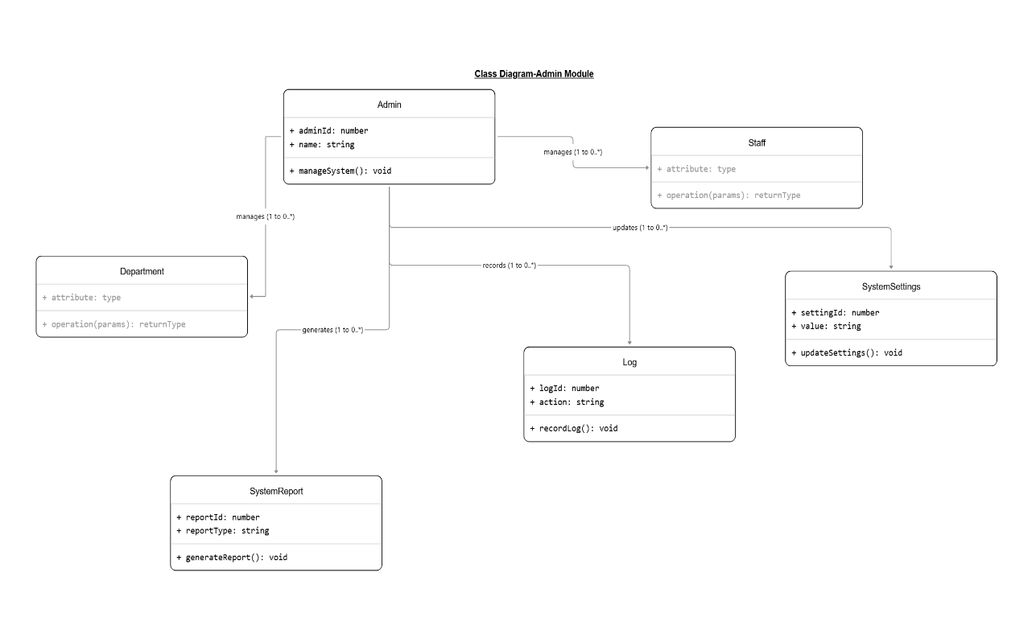

6. Notification Module:-

- Description :-

- Users receive updates about their complaints from the Notification Module.
- When the status of a complaint changes, notifications are automatically sent.
- The notification's delivery status is verified by the system.
- This module keeps users updated on the status of their complaints.
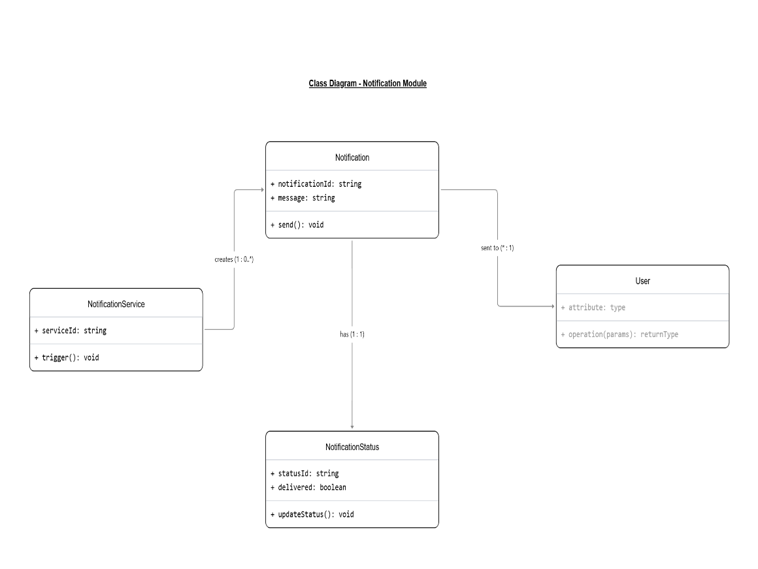

7. Report & Analytics Module:-

- Description:-

- The system's complaint data is analysed using the Report and Analytics Module.
- Using the Analytics class, it computes the total number of complaints, pending complaints, and resolved complaints.
- To assess department performance, department-specific reports are created using the department report class.
- To assist administrators in making system improvements, the Trend class is used to examine complaint patterns over time, such as monthly or annual trends.

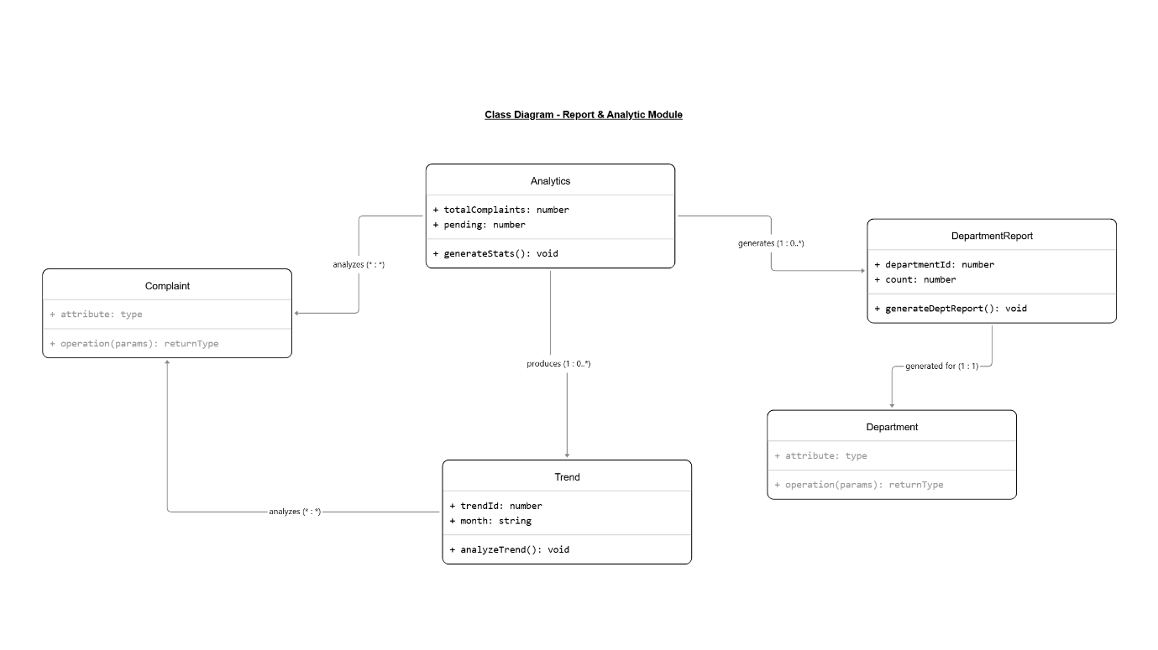

C)State chart Diagram:-

Module Name:- Complaint Registration Module

1.Compliant Object:-

- Description:-

          - The Complaint object starts in Draft state when the user is entering complaint details.
          - After submission, it moves to Submitted and Under Review states for system verification.
          - Finally, it reaches Registered and Closed states when the complaint is accepted and resolved.

- States Involved:-

- Draft
- Submitted
- Under Review
- Registered
- Closed

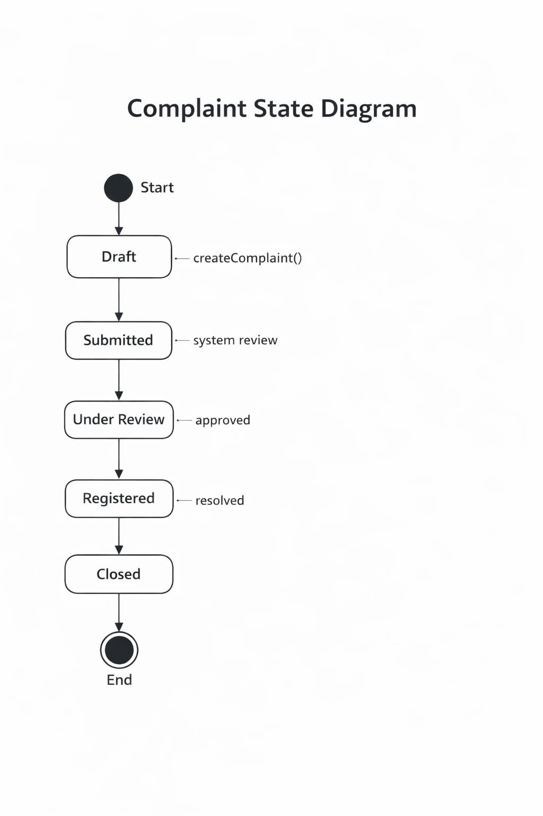
2.AttachmentObject:-

- Description:-

- Before the user uploads any files, the Attachment object is in the Not Uploaded state.
- After upload, it moves to Uploaded and Verified states for file validation.
- When the file is connected to the complaint, it finally reaches the Attached state.

- States Involved:-

- Not Uploaded
- Uploaded
- Verified
- Attached
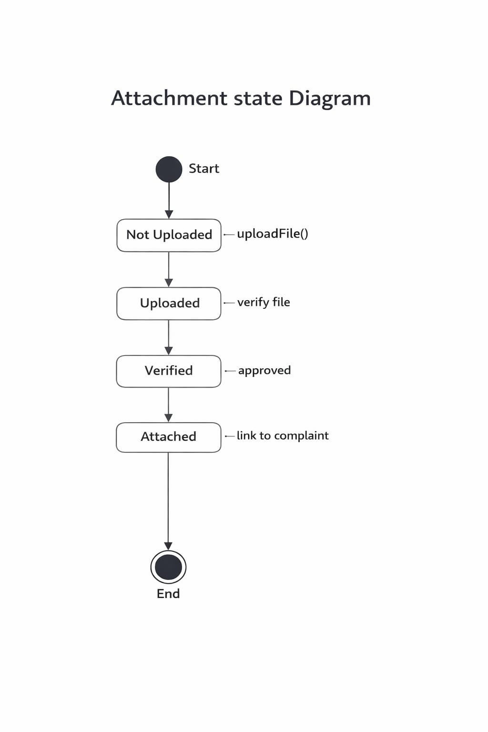
3.ComplaintType Object :-

- Description:-

- Prior to choosing the complaint category, the Complainttype object is in the Undefined state.
- When the user selects the type of complaint, it goes to the Selected state.
- When the type is saved with the complaint, it finally reaches the Assigned state.

- States Involved:-

- Undefined
- Selected
- Assigned

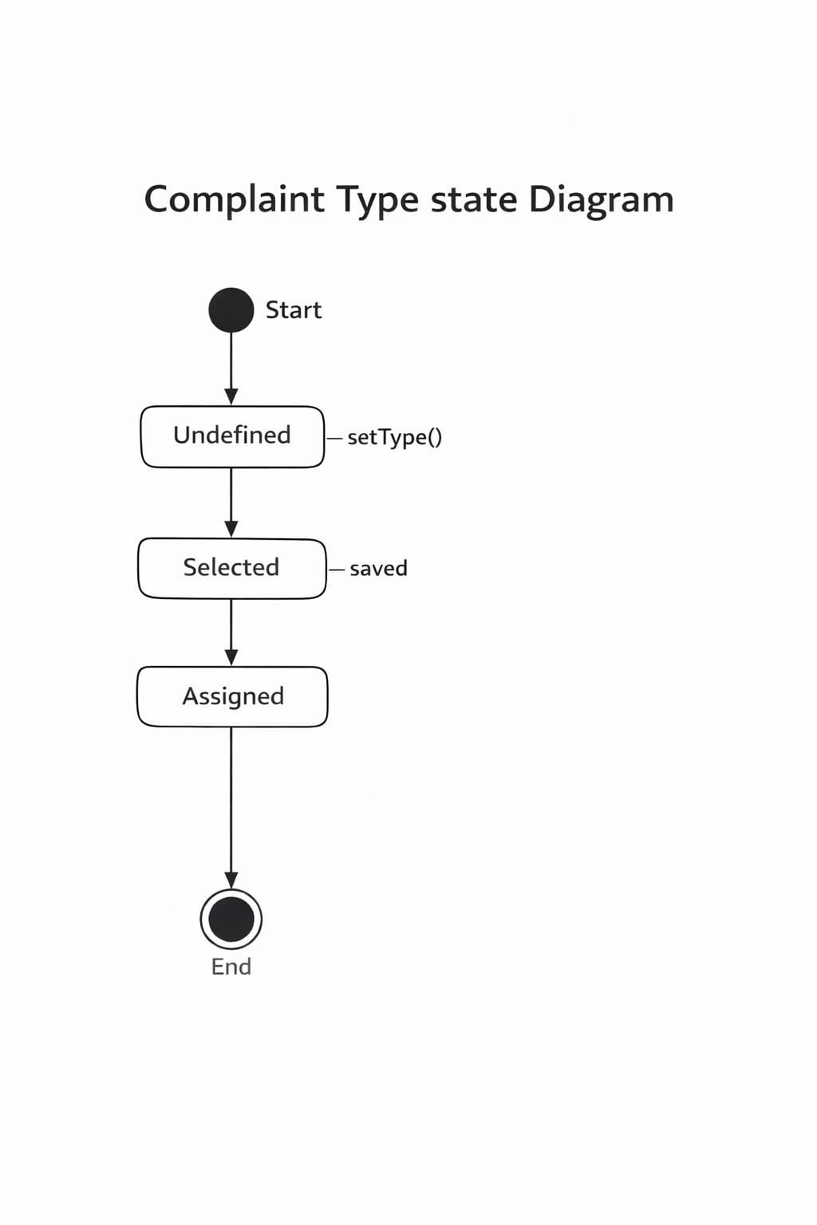

4.Priority Object:-

- Description:-

- Prior to assigning an urgency level, the Priority object is initially in the Not Set state.
- When the user chooses a priority, it shifts to a Low, Medium, or High state.
- When the priority is saved in the system, it eventually reaches the Assigned state.

- States Involved:-

- Not set
- Low/Medium/High
- Assigned
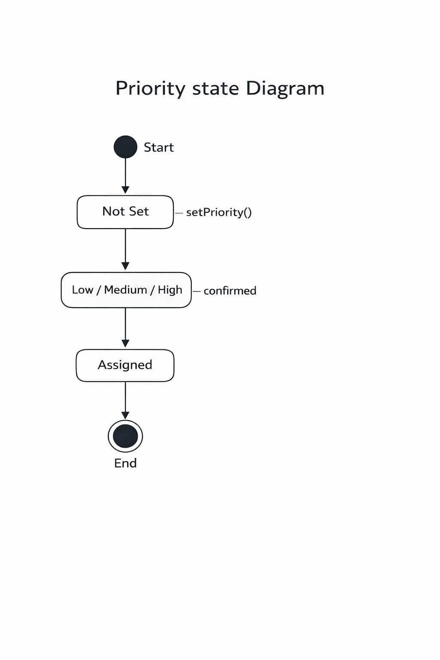

d)Activity Diagram :-

1.Module Name:- Complaint Tracking Module

- Description:-

- The activity diagram shows how a user logs into the system and selects the option to track a complaint using the complaint ID.
- The system checks the complaint status and uses a decision point to determine whether the complaint is resolved or still pending.
- Finally, the system displays the complaint status, history details, and ends the process.

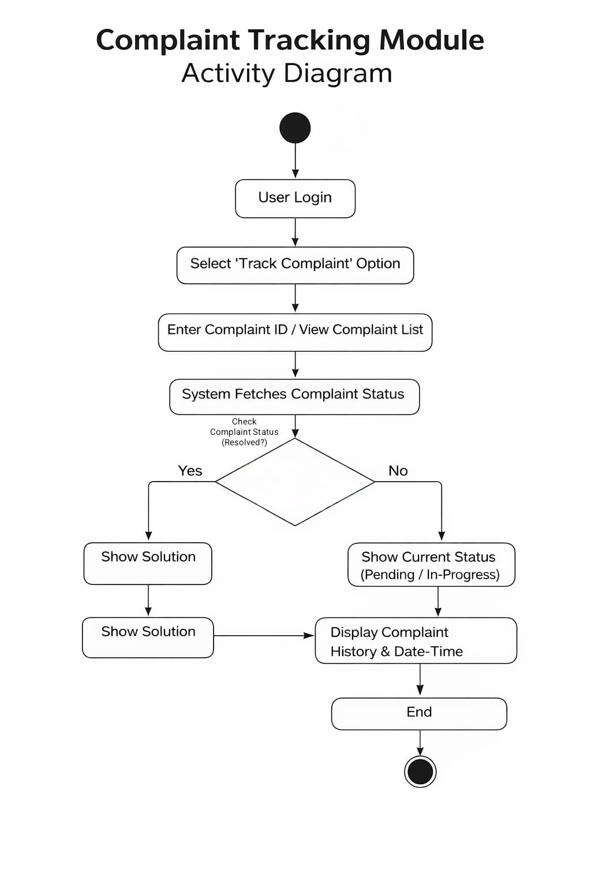
2.Module Name:-Admin Module

- Description :-

- The admin logging in and the system confirming the admin credentials are the first steps in the activity diagram.
- After successful login, the admin performs activities like managing departments, staff, assigning complaints, and generating reports.
- The process ends when the admin logs out of the system.
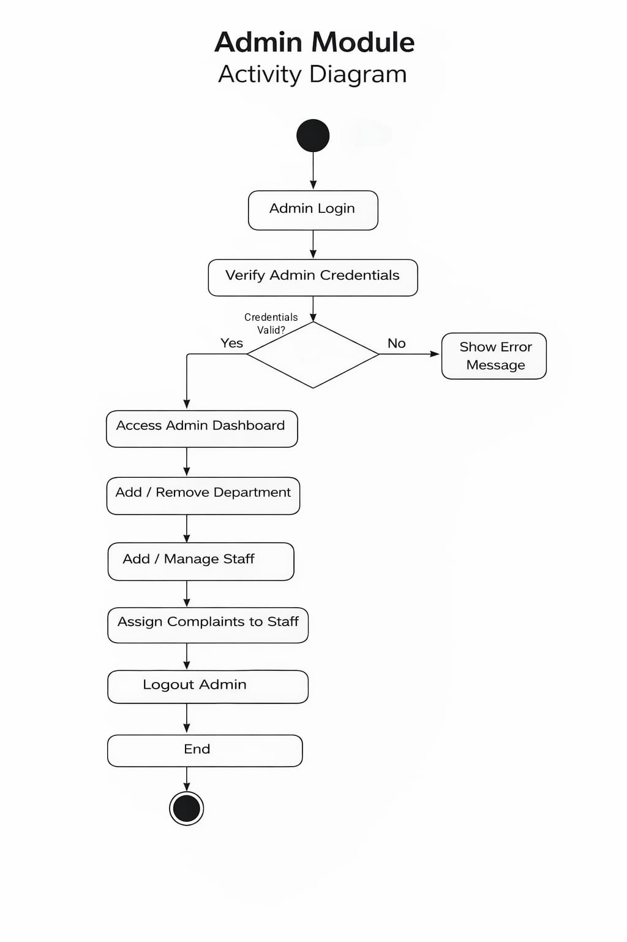
e)Sequence Diagram :-

1.Module Name:- user Management Module

- Description:-

- This diagram illustrates the process of a user logging in and requesting their profile.
- The system processes the user and retrieves their profile step by step.
- A role is then assigned to the user depending on their permission level.
- Lastly, a login session is initiated to enable the user to safely access the system.
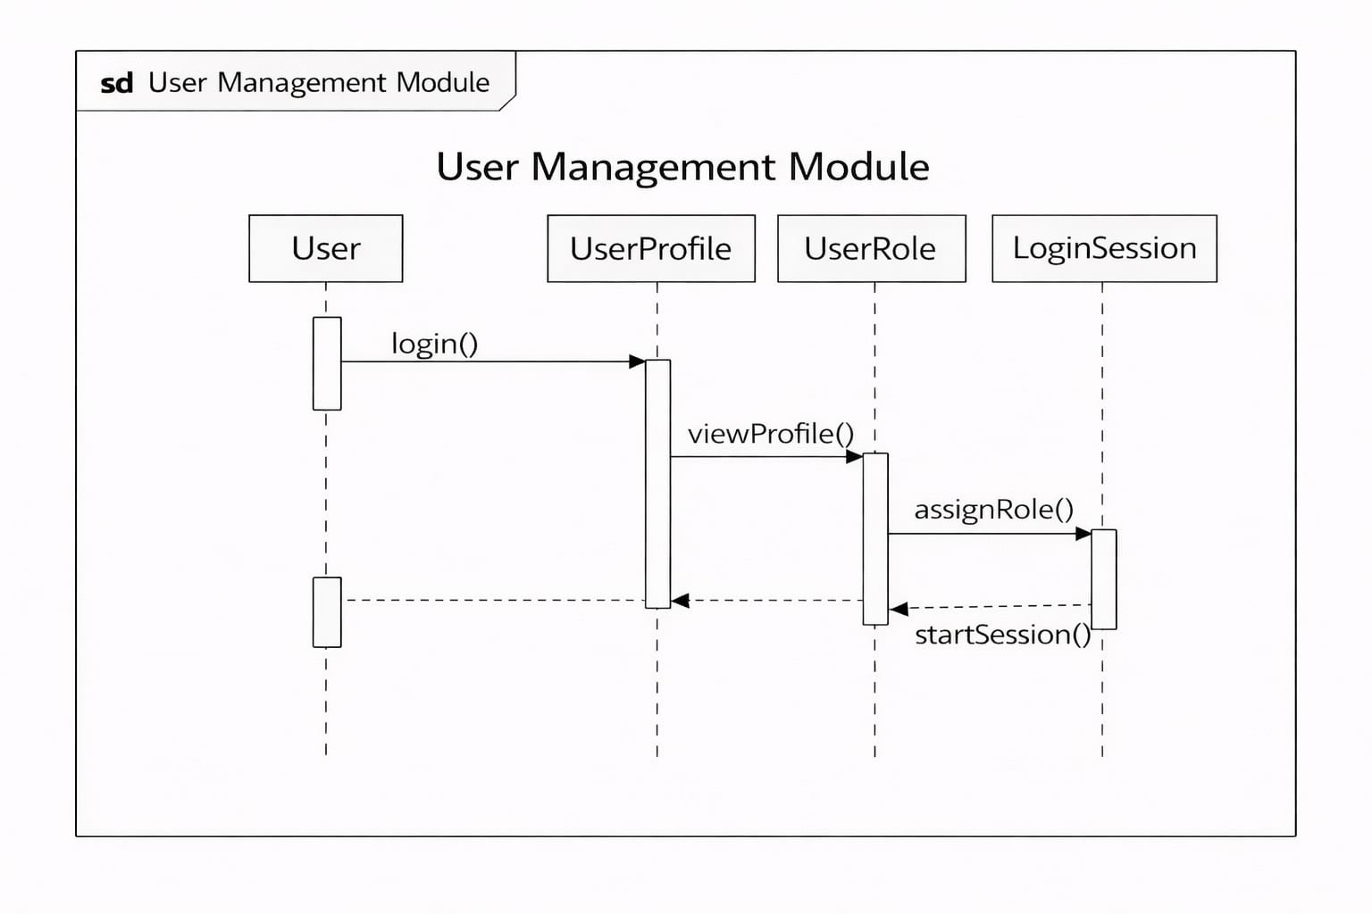
2.ModuleName:- Complaint Registration Module

- Description:-

- This diagram illustrates the process of a user logging in and requesting their profile.
- The system processes the user and retrieves their profile step by step.
- A role is then assigned to the user depending on their permission level.
- Lastly, a login session is initiated to enable the user to safely access the system.
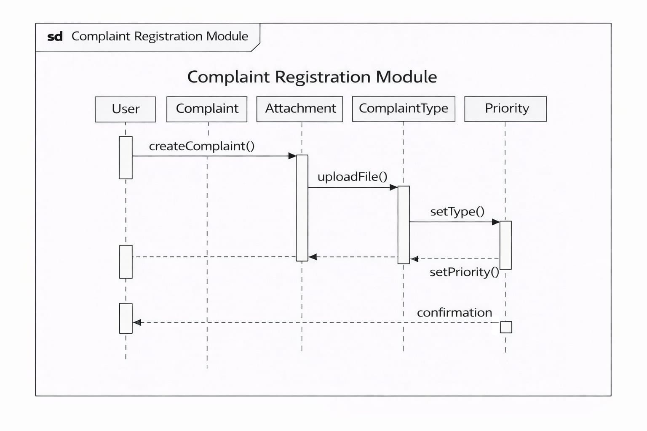
3.Module Name: Complaint Tracking Module

- Description:-

- In this diagram, the user uses the system to monitor the status of their complaint.
- The user can also view the status changes to ensure transparency.
- Feedback is provided.
- The final results are sent to the user after the process.
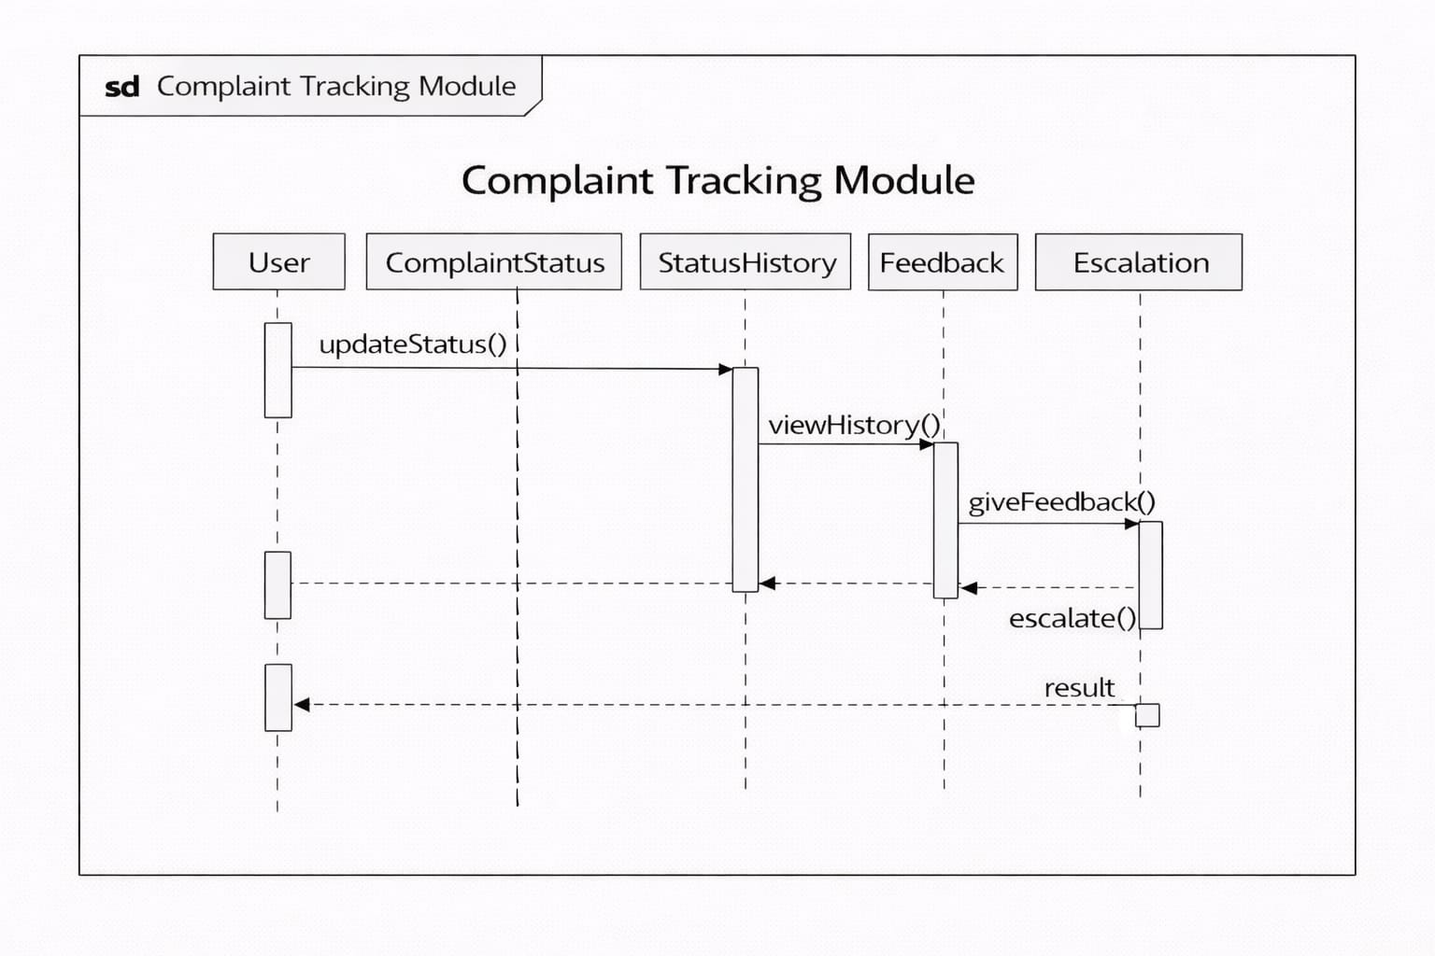

f) Collaboration Diagram:-

1.Module Name:-User Management Module

- Description:-

- The diagram depicts the interaction among user, profile, role, and session objects.
- Each object communicates with the others using a set of numbered messages.
- It depicts the cooperation among the components of the system.
- It does not depict the flow of time.
- It depicts the process of user role assignment and the establishment of a secure session.
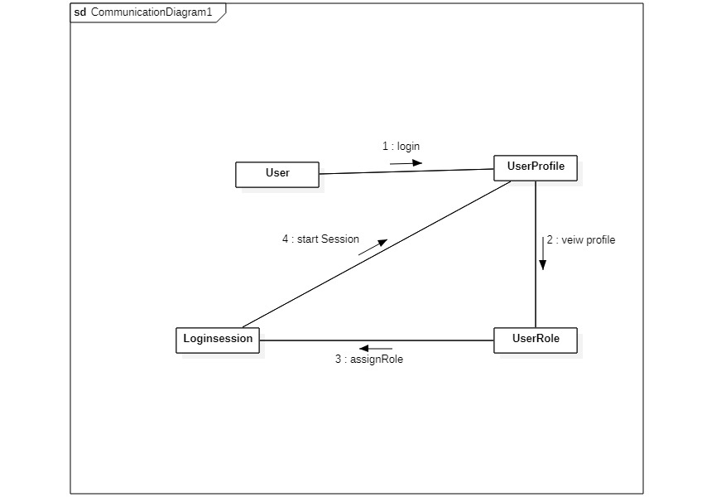
User Management Collaboration Diagram

2.ModuleName :-Complaint Registration Module

- Description:-

- The diagram depicts the interaction among the complaint, attachment, type, and priority objects.
- It depicts the cooperation among the components of the system.
- It does not depict the flow of time.
- It depicts the cooperation among the components of the system.

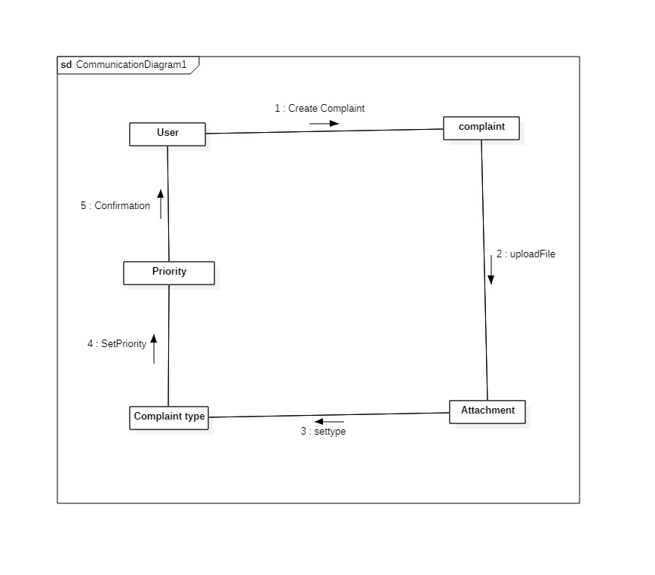
Complaint Registration Collaboration Diagram

3.ModuleName:-Complaint Tracking Module

- Description:-

- The diagram illustrates the cooperation of the status, feedback, and escalation components.
- Messages describe the process of complaint tracking and updating.
- It emphasizes the relationships rather than the events.
- It illustrates the teamwork of the tracking objects.
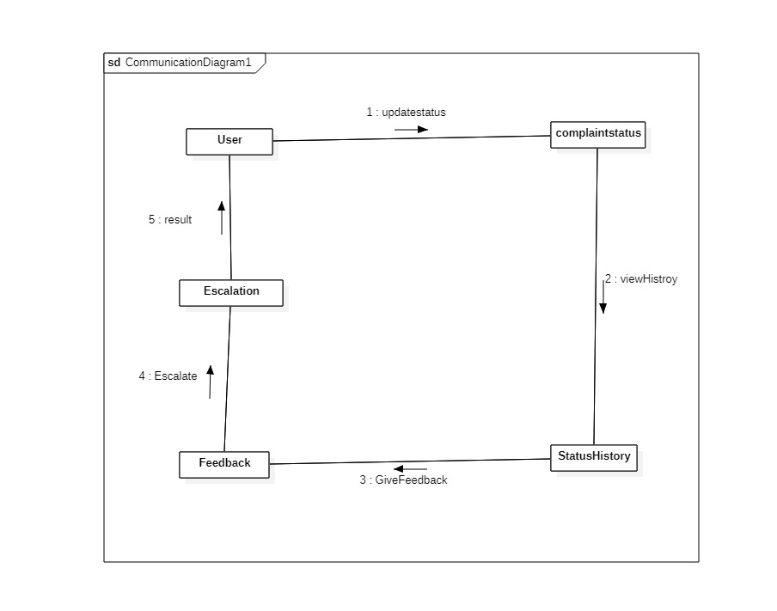
Complaint Tracking Collaboration Diagram

3.2 Entity Relationship Diagram (ER Diagram):-

- Description:-

- The ER diagram illustrates the database structure of the Complaint Management System.
- The diagram indicates how the data in the database is organized.
- The User entity holds personal details.
- The entity also allows users to lodge multiple complaints.
- The Complaint entity holds the main data.
- It connects users, departments, and complaint statuses.
- Each complaint is linked to a Department that addresses the complaint.
- The Staff entity holds details about employees working in departments.
- The employees handle complaints.
- The Complaint Status entity keeps track of the complaint’s status, whether it is pending, in progress, or done.
- The Admin entity oversees everything. It oversees the complaint process.

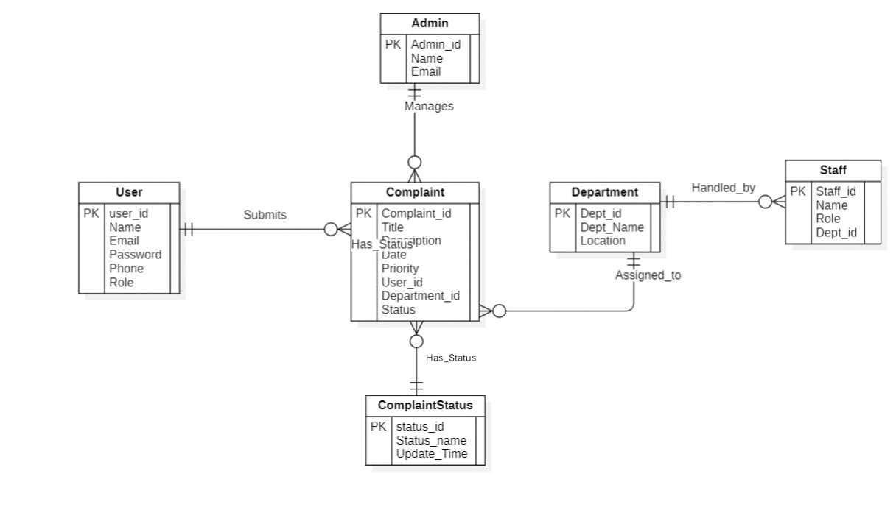
Complaint Management System ER Diagram

3.3 Data Flow Diagram (DFD):-

- Description:-

- The Level-1 DFD illustrates the flow of complaints within the system, from the time they are lodged to the time they are resolved.
- The user logs in or registers through the User Management module. The user’s details are stored in the User Database.
- The user then submits complaints, which are stored in the Complaint Database.
- The Complaint Tracking module retrieves complaint updates to show the user the progress of their complaints.
- The complaints are then routed to departments for action.
- The departmental staff update the complaint status and send the outcome back to the system through their module.
- The Admin module oversees the allocation of tasks and keeps departmental records.
- The modules interact with each other in a continuous flow to ensure that all records are up to date.
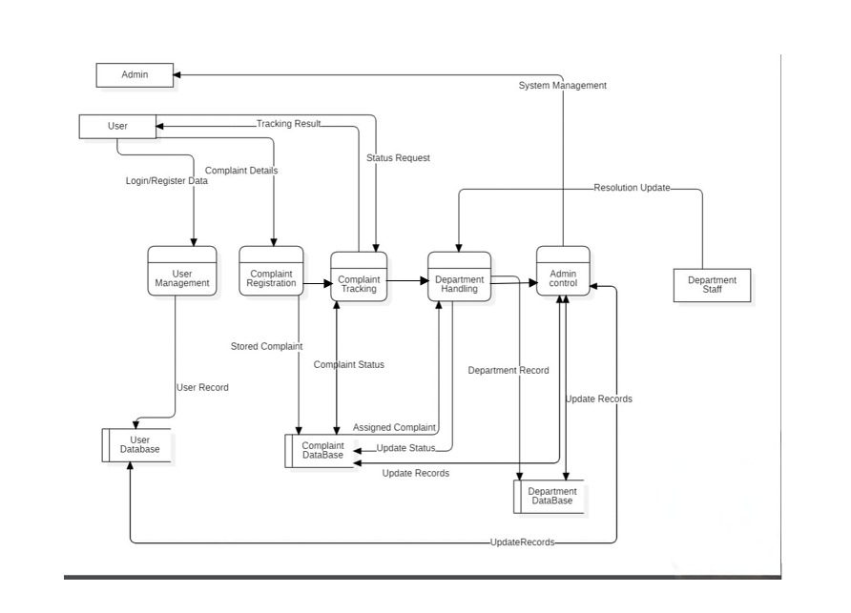
Complaint Management System Level-1 DFD Diagram
4.External Interface Requirements/Screenshots:-

- Description:-

- The interactions between the Complaint Management System and other software, devices, people, and communication networks are described in this chapter.
- These user interfaces specify how the system operates in the actual world and how users interact with it on a daily basis

4.1 User Interfaces:-

- The system's user interface is its most noticeable component. It establishes how simple it is for users to file complaints and monitor developments.
- Even novice users without technical expertise can file complaints thanks to the system's clear and easy-to-use interface. Every screen is made to clear up confusion and provide step-by-step instructions to users.
- Administrators, employees, and students can all access different dashboards. To avoid abuse and maintain an uncluttered interface, each role only sees the features that are pertinent to their duties.
- To guarantee accurate data entry, complaint submission forms feature date pickers, dropdown menus, and guided fields. This increases the accuracy of complaints and lowers typing errors.
- Users can quickly comprehend system updates by viewing the complaint status visually using progress indicators like pending, in progress, and resolved.
- Users can engage with the system from any location thanks to the responsive interface, which adjusts to desktop computers, tablets, and smartphones.
- All user categories can continue to use the interface thanks to accessibility features like readable fonts, appropriate contrast, and easy navigation.

4.2 Hardware Interfaces:-

- The physical environment needed to run the system dependably is described by hardware interfaces.
- The Complaint Management System doesn't require specialized hardware to operate on common computing devices like desktops, laptops, or smartphones.
- To keep track of complaints and continuously respond to user requests, a dedicated server or cloud host is needed. This guarantees the system's constant availability.
- Keyboards, mice, and touchscreens are adequate input devices for all system functions. Advanced hardware training is not necessary.
- To preserve long-term records and safeguard complaint data, secure storage hardware must be accessible. System trust is directly impacted by storage reliability.
- External storage or backup hardware is advised to guard against data loss in the event of unplanned malfunctions or natural disasters.
- For continuous complaint submission and tracking, network hardware, including switches and routers, must provide reliable internet connectivity.

4.3 Software Interfaces:-

- Software interfaces specify how a system interacts with other applications and electronic devices.
- To guarantee compatibility and stability, the system runs on contemporary operating systems like Windows or Linux.
- User profiles, history logs, and complaints are safely stored in relational or non-relational database systems such as MySQL or MongoDB.
- Users don't need to install extra software because web browsers serve as the primary access point.
- Behind the scenes, backend software handles status updates, complaint routing, and authentication.
- It is possible to integrate email or SMS gateway APIs to automatically update users on the status of their complaints.
- The system ensures security patches and ongoing improvement by supporting software updates without interfering with active users.

4.4 Communication Interfaces:-

- The flow of data between users and the system is described by communication interfaces.
- The system safely sends complaint data over the internet using secure HTTP/HTTPS protocols.
- To prevent unwanted access to personal information, all communications are encrypted.
- Internal modules and external services can interact seamlessly thanks to REST-based communication.
- The system can be used in office or campus networks because it supports LAN and Wi-Fi environments.
- Reliable connectivity is crucial because user access is directly impacted by network availability.
- The system is built to withstand brief disruptions in communication without erasing complaint data that has been stored.

5.Non-Functional Requirements:-

- Description:-

- Non-functional requirements explain the system's performance rather than just its functionality.
- These specifications emphasize speed, safety, dependability, and overall system quality.

5.1 Performance Requirements:-

- Performance requirements guarantee that the system functions properly when actually used.
- To ensure a seamless user experience, the system must react to user actions in less than two seconds under typical circumstances.
- It should be able to handle several users filing complaints at once without experiencing any lag.
- Optimizing database operations is necessary for speedy complaint retrieval and updates.
- During busy times, like workdays or deadlines, the system ought to stay stable.
- For users to see accurate information, complaint status updates must be processed almost instantly.
- To avoid server overload, resource usage, including CPU and memory, must be balanced.

5.2 Safety Requirements:-

- Safety regulations shield the system from malfunctions and unintentional data loss.
- Regular automatic backups are necessary to safeguard complaint files.
- After crashes, the system ought to bounce back fast without erasing any data that has been stored.
- Technical details should not be revealed in error messages; instead, they should be easy to understand.
- To track system behavior during failures, activity logs must be kept up to date.
- The system shouldn't shut down if one module fails.
- Secure storage systems guard against complaints being inadvertently erased or overwritten.

5.3 Security Requirements:-

- Security ensures that only authorized persons can access sensitive information related to complaints.
- The system should require users to log in with correct credentials before accessing the system.
- Passwords should be encrypted, not in plain text.
- The system should allow users to perform specific tasks based on their roles.
- Sensitive information related to complaints should remain encrypted during transmission.
- The system should protect accounts from repeated failed login attempts.
- The system should perform security checks periodically to detect security vulnerabilities.

5.4 Software Quality Attributes:-

- These attributes determine the long-term quality of the software in terms of reliability and usability.
- The system should run continuously with little downtime.
- The system interface should remain simple, allowing users to use the system without training.
- The system architecture should allow for easy upgrades in the future.
- Maintenance of the system should be easy.
- It should function in the same way under different usage scenarios.
- Code should be of professional quality to minimize bugs.

5.5 Business Policies / Rules :-

- Business rules dictate the operation of the system within the limits of the institution.
- Complaints should be filed following the official procedures established by the institution.
- Only registered users should be allowed to file complaints.
- Timeliness of complaints should be in line with the institution’s service standards.
- Privacy of users should be in accordance with the laws on data protection.
- Complaints should be retained for the specified period.
- Actions should be recorded to ensure accountability.
6.Testing:

6.1 White Box Testing:
Module Name : User Management Module
Sample Code-1:

class User:
def __init__(self):
self.user_id = 0
self.username = ""
self.password = ""
self.role = ""
def register(self, uid, u, p, r):
if uid <= 0:
print("User ID must be greater than 0")
return False
if u == "" or p == "" or r == "":
print("Fields cannot be empty")
return False
self.user_id = uid
self.username = u
self.password = p
self.role = r
print("User Registered Successfully")
return True
def login(self, u, p):
if self.username == u and self.password == p:
return True
else:
return False
def show_profile(self):
print("User ID :", self.user_id)
print("Username :", self.username)
print("Role :", self.role)
obj = User()
print("Register User")
uid = int(input("Enter User ID : "))
u = input("Enter Username : ")
p = input("Enter Password : ")
r = input("Enter Role : ")
if obj.register(uid, u, p, r):
print("\nLogin")
lu = input("Enter Username : ")
lp = input("Enter Password : ")
if obj.login(lu, lp):
print("Login Successful")
obj.show_profile()
else:
print("Login Failed")

6.1.1 Flow Graph Notation

- Control flow depicts a program as a graph that consists of Nodes and Edges.
- In the graph, Nodes represent processing tasks while edges represent control flow between the nodes.

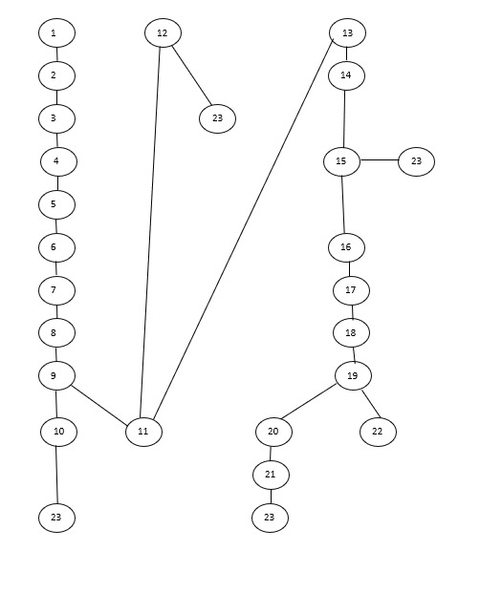
Flow graph notation for aSample Code-1
6.1.2 Cyclomatic Complexity
(Using Graph Method)

Here N= 23

E= 26

Where E= Number of edges

​​N= Number of nodes

V(G) = E-N+2

V(G) = 26-23+2 =5

Independent Paths (5 paths required)
Because complexity = 5, we must write 5 independent paths.
Path 1
1 → 2 → 3 → 4 → 5 → 6 → 7 → 8 → 9 → 10 → 23
Path 2
1 → 2 → 3 → 4 → 5 → 6 → 7 → 8 → 9 → 11 → 12 → 23
Path 3
1 → 2 → 3 → 4 → 5 → 6 → 7 → 8 → 9 → 11 → 13 → 14 → 15 → 23
Path 4
1 → 2 → 3 → 4 → 5 → 6 → 7 → 8 → 9 → 11 → 13 → 14 → 15 → 16 → 17 → 18 → 19 → 20 → 21 → 23
Path 5
1 → 2 → 3 → 4 → 5 → 6 → 7 → 8 → 9 → 11 → 13 → 14 → 15 → 16 → 17 → 18 → 19 → 22 → 23

- Independent Paths & Test

Path No | Independent Path | Test Input | Excepted Output
P1 | 1,2,3,4,5,6,7,8,9,10,23 | Invalid User ID | Registration failed
P2 | 1,2,3,4,5,6,7,8,9,11,12,23 | Empty Fields | Fields Cannot Be empty
P3 | 1,2,3,4,5,6,7,8,9,11,13,14,15,23 | Valid Register but no login | User registered
P4 | 1,2,3,4,5,6,7,8,9,11,13,14,15,16,17,18,19,20,21,23 | Correct Login | Login Successful
P5 | 1,2,3,4,5,6,7,8,9,11,13,14,15,16,17,18,19,22,23 | Wrong Login | Login Failed

6.1.4 Implement Unit Tests (Execution Phase):

Convert the above table into Python unittest

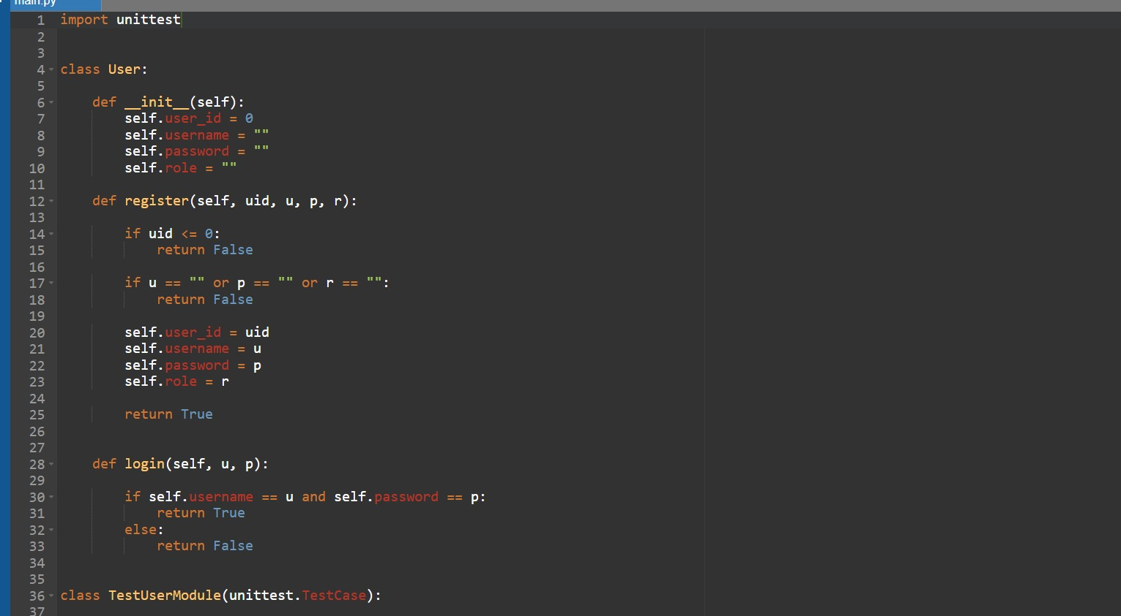
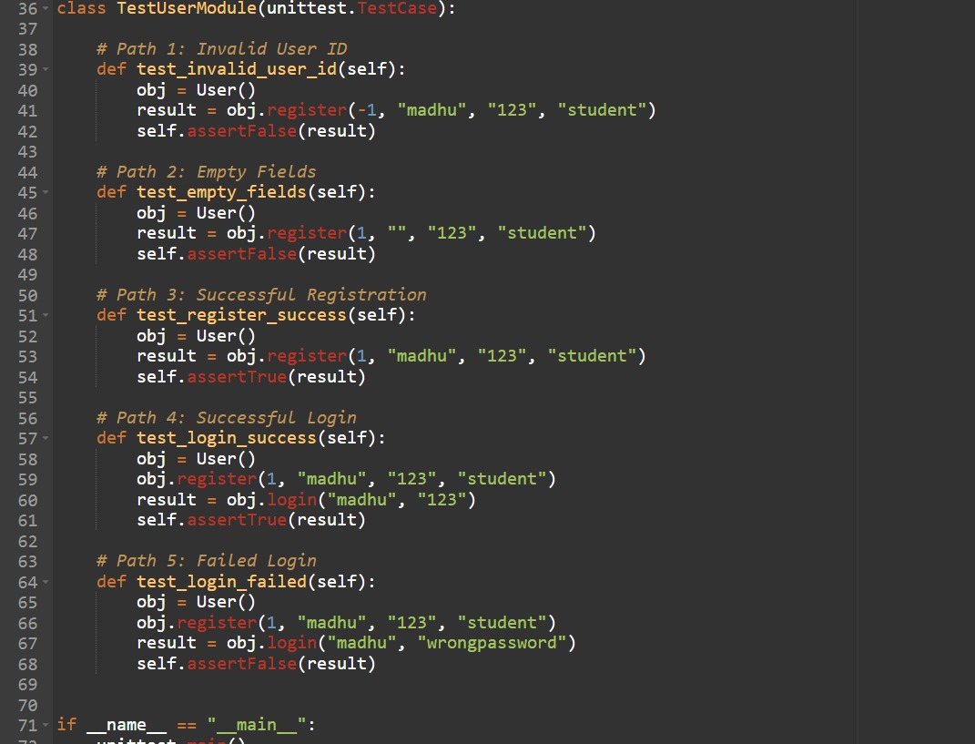

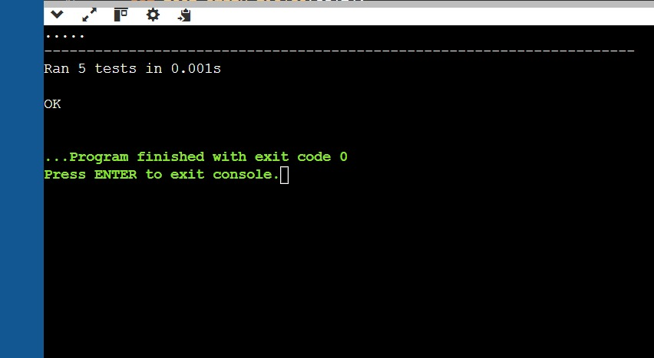

All tests passed
So, white-box testing is Successful.
6.2 Black-Box Testing:

Functional behavior verified without analyzing internal code.

Module Name : User Management Module
Sample Code-1:

class User:
def __init__(self):
self.user_id = 0
self.username = ""
self.password = ""
self.role = ""
def register(self, uid, u, p, r):
if uid <= 0:
print("User ID must be greater than 0")
return False
if u == "" or p == "" or r == "":
print("Fields cannot be empty")
return False
self.user_id = uid
self.username = u
self.password = p
self.role = r
print("User Registered Successfully")
return True
def login(self, u, p):
if self.username == u and self.password == p:
return True
else:
return False
def show_profile(self):
print("User ID :", self.user_id)
print("Username :", self.username)
print("Role :", self.role)
obj = User()
print("Register User")
uid = int(input("Enter User ID : "))
u = input("Enter Username : ")
p = input("Enter Password : ")
r = input("Enter Role : ")
if obj.register(uid, u, p, r):
print("\nLogin")
lu = input("Enter Username : ")
lp = input("Enter Password : ")
if obj.login(lu, lp):
print("Login Successful")
obj.show_profile()
else:
print("Login Failed")

Step-1: Write Functional Requirements (From Problem Statement)

Functional Requirements (Black Box Testing):

- User Registration

- The system should allow a user to register by entering User ID, Username, Password, and Role.

- User ID Validation

- The system should check that User ID is greater than 0.
- If User ID is 0 or negative, registration should fail.

- Empty Field Validation

- The system should verify that Username, Password, and Role are not empty.
- If any field is empty, registration should fail.

- Successful Registration

- If all inputs are valid, the system should store the user details and display “User Registered Successfully”.

- User Login

- After successful registration, the system should allow the user to login using username and password.

- Login Authentication

- The system should compare entered username and password with stored values.

- Successful Login

- If username and password match, the system should display “Login Successful”.

- Failed Login

- If username or password is incorrect, the system should display “Login Failed”.

- Display User Profile

- After successful login, the system should display User ID, Username, and Role.

- Program Flow

- Login should be allowed only if registration is successful.

Step-2: Black Box Testing Techniques

2.1 Equivalence Partitioning:

- Equivalence Partitioning – Registration Module

Input Field | Valid Partition | Invalid Partition | Example valid value | Example invalid value
User id | ID>0 | ID<-0 | 1 | 0,-5
User Name | Not Empty | Empty string | “ madhu” | “”
Password | Not Empty | Empty String | “ 123” | “”
Role | Not Empty | Empty String | “ Student” | “”

- Equivalence Partitioning Test Cases (Registration)

Test Case ID | User ID | Username | Password | Role | Partition Type | Expected Result
TC1 | 1 | madhu | 123 | student | Valid | User Registered Successfully
TC2 | 0 | madhu | 123 | student | Invalid User ID | Registration Failed
TC3 | -5 | madhu | 123 | student | Invalid User ID | Registration Failed
TC4 | 1 | "" | 123 | student | Invalid Username | Fields cannot be empty
TC5 | 1 | madhu | "" | student | Invalid Password | Fields cannot be empty
TC6 | 1 | madhu | 123 | "" | Invalid Role | Fields cannot be empty

- Equivalence Partitioning – Login Module

Input Field | Valid Partition | Invalid Partition | Example valid value | Example invalid value
User name | Correct user name | Incorrect user name | madhu | wronguser
password | Correct Password | Incorrect password | 123 | Wrong password

- Equivalence Partitioning Test Cases (Login)

Test Case ID | Username | Password | Partition Type | Expected Result
TC7 | madhu | 123 | Valid | Login Successful
TC8 | wronguser | 123 | Invalid Username | Login Failed
TC9 | madhu | wrongpass | Invalid Password | Login Failed

2.2 Boundary Value Analysis:

- Boundary Value Analysis – User ID

Test Case ID | User ID Value | Boundary Type | Expected Result
TC1 | -1 | Just below boundary | User ID must be greater than 0
TC2 | 0 | Boundary value | User ID must be greater than 0
TC3 | 1 | Just above boundary | Registration Successful

- Boundary Value Analysis – Username

Test Case ID | Username | Boundary Type | Expected Result
TC4 | "" | Lower boundary (empty) | Fields cannot be empty
TC5 | "a" | Just above boundary | Accepted

- Boundary Value Analysis – Password

Test Case ID | Password | Boundary Type | Expected Result
TC6 | "" | Lower boundary | Fields cannot be empty
TC7 | "1" | Just above boundary | Accepted

- Boundary Value Analysis – Role

Test Case ID | Role | Boundary Type | Expected Result
TC8 | "" | Lower boundary | Fields cannot be empty
TC9 | "s" | Just above boundary | Accepted

- Boundary Value Analysis – Login

Test Case ID | Username | Password | Boundary Type | Expected Result
TC10 | correct | correct | Valid boundary | Login Successful
TC11 | wrong | correct | Username boundary | Login Failed
TC12 | correct | wrong | Password boundary | Login Failed

Run the Program manually or using function calls.

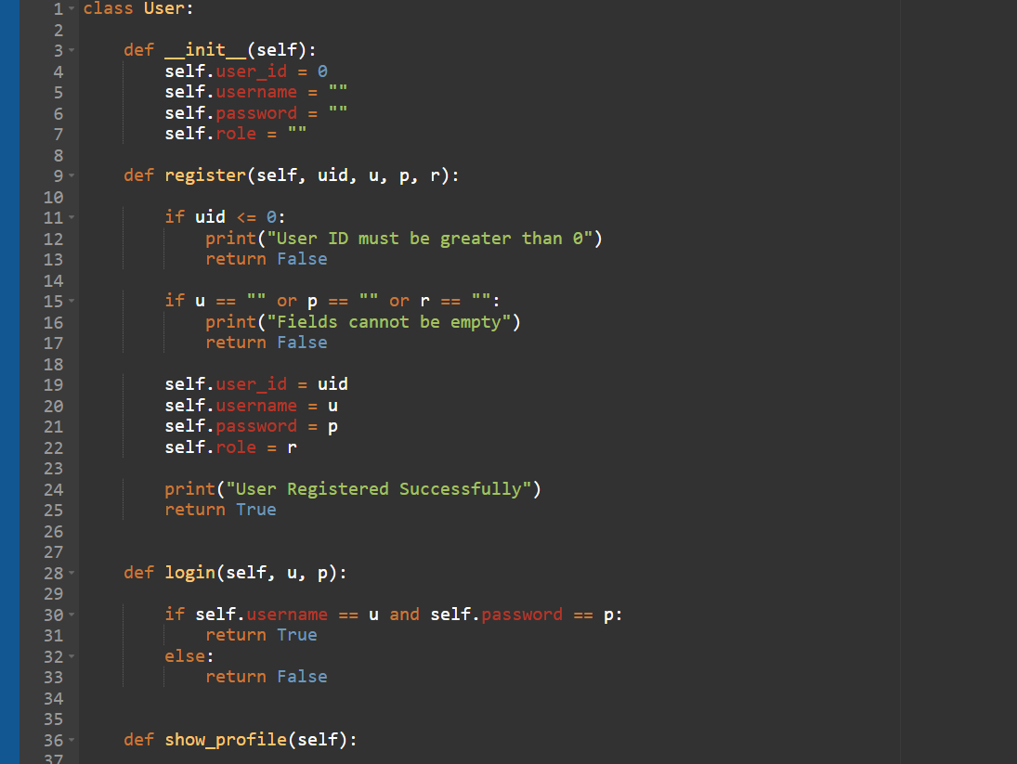

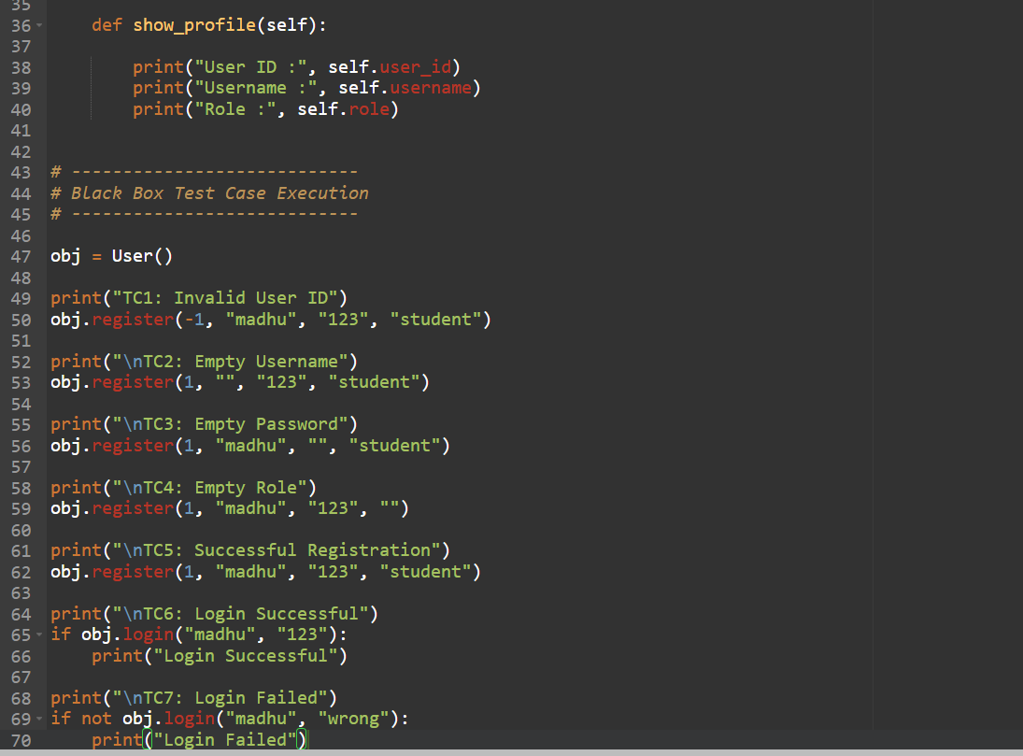

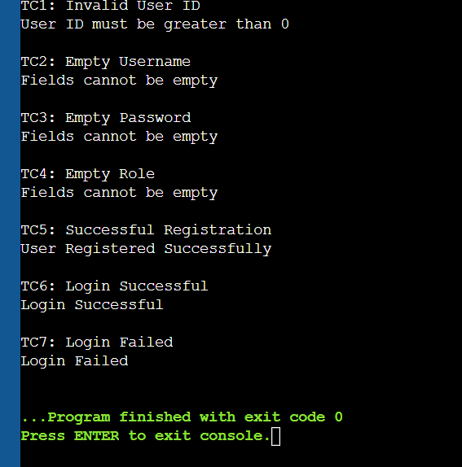

The Output is matched to all the above test cases mentioned in table, then Black Box testing is successful.
6.Testing:

6.1 White Box Testing:
Module Name : Complaint Registration Module
Sample Code-2:

class Complaint:
def __init__(self):
self.id = 0
self.title = ""
self.description = ""
self.department = ""
def register_complaint(self, i, t, d, dep):
self.id = i
self.title = t
self.description = d
self.department = dep
print("Complaint Registered Successfully")
def show_complaint(self):
print("\nComplaint Details")
print("ID :", self.id)
print("Title :", self.title)
print("Description :", self.description)
print("Department :", self.department)
obj = Complaint()
i = int(input("Enter Complaint ID : "))
if i <= 0:
print("Invalid Complaint ID")
exit()
t = input("Enter Title : ")
if t == "":
print("Title cannot be empty")
exit()
d = input("Enter Description : ")
if d == "":
print("Description cannot be empty")
exit()
dep = input("Enter Department : ")
if dep == "":
print("Department cannot be empty")
exit()
obj.register_complaint(i, t, d, dep)
obj.show_complaint()

6.1.1 Flow Graph Notation

- Control flow depicts a program as a graph that consists of Nodes and Edges.
- In the graph, Nodes represent processing tasks while edges represent control flow between the nodes.

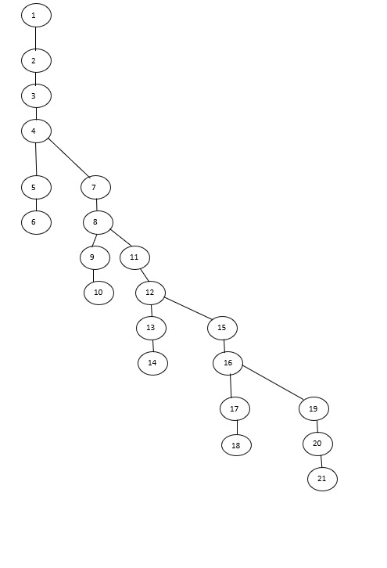

Flow graph notation for aSample Code-2

6.1.2 Cyclomatic Complexity
(Using Graph Method)

Here N= 21
E= 24
Where E= Number of edges
​​N= Number of nodes
V(G) = E-N+2
V(G) =24-21+2 =5
Cyclomatic Complexity = 5

- Independent Paths & Test

Path No | Independent Path (Node Sequence) | Test Input | Expected Output
P1 | 1,2,3,4,5,6 | ID = -1 | Invalid Complaint ID
P2 | 1,2,3,4,7,8,9,10 | ID=10, Title="" | Title cannot be empty
P3 | 1,2,3,4,7,8,11,12,13,14 | ID=10, Title="Network", Description="" | Description cannot be empty
P4 | 1,2,3,4,7,8,11,12,15,16,17,18 | ID=10, Title="Network", Desc="Internet issue", Dept="" | Department cannot be empty
P5 | 1,2,3,4,7,8,11,12,15,16,19,20,21 | ID=10, Title="Network", Desc="Internet issue", Dept="IT" | Complaint Registered Successfully

6.1.4 Implement Unit Tests (Execution Phase):

​
Convert the above table into Python unittest.

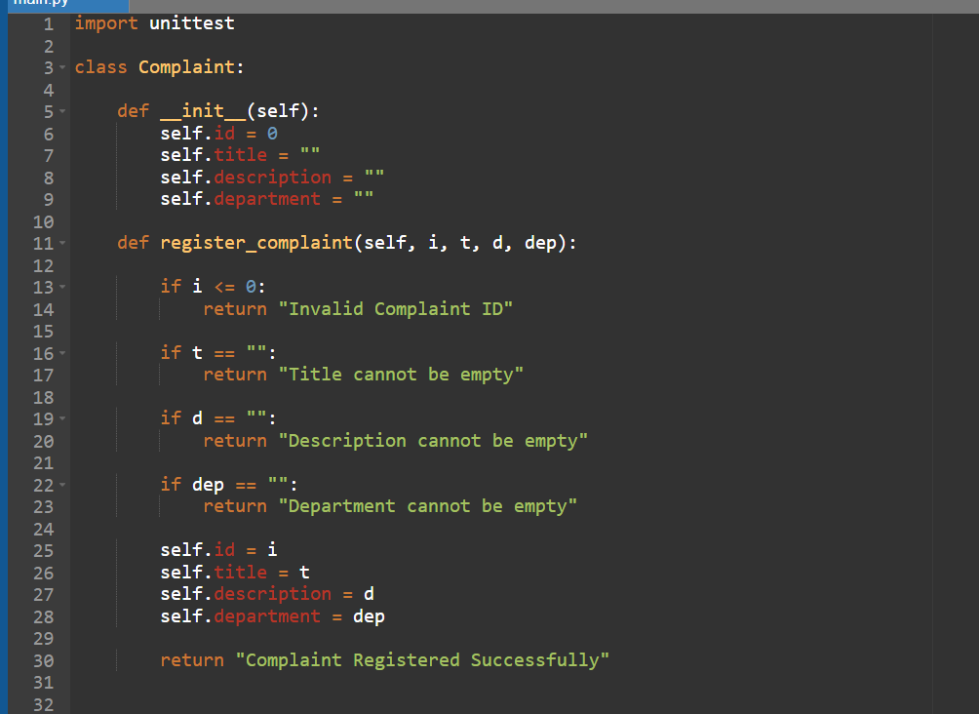
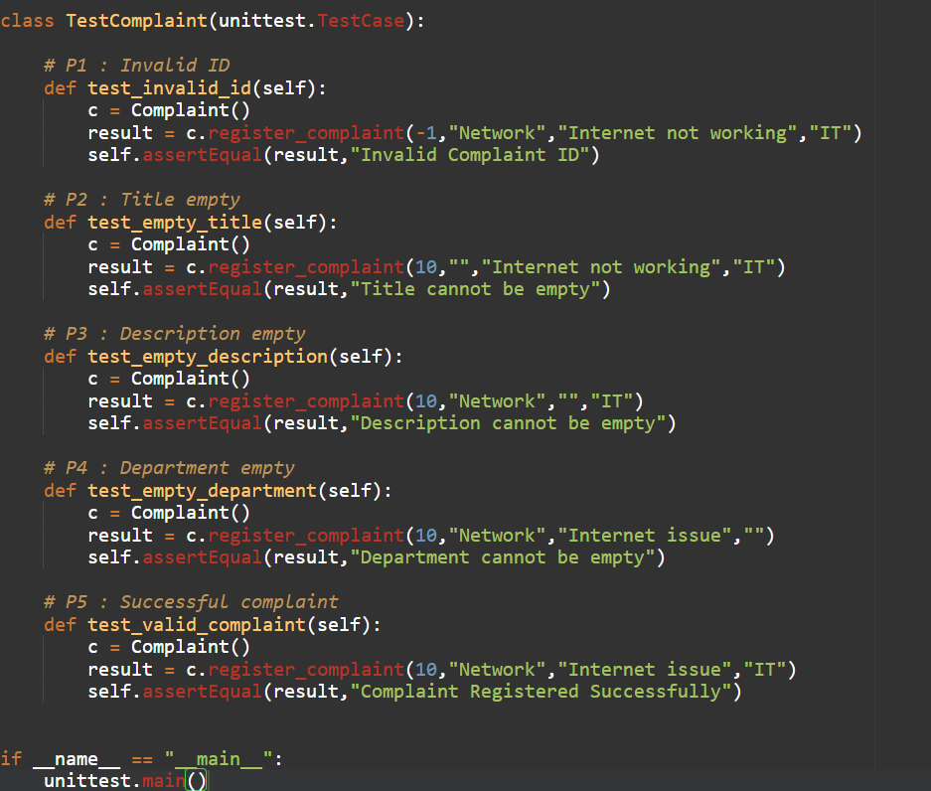

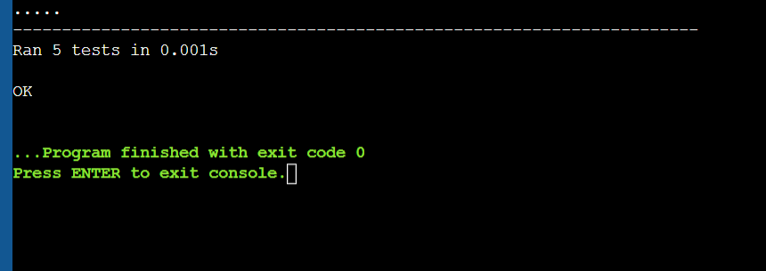

All tests passed
So, white-box testing is Successful.

6.2 Black-Box Testing:

- Functional behavior verified without analyzing internal code.

Module Name : Complaint Registration Module
Sample Code-2:

class Complaint:
def __init__(self):
self.id = 0
self.title = ""
self.description = ""
self.department = ""
def register_complaint(self, i, t, d, dep):
self.id = i
self.title = t
self.description = d
self.department = dep
print("Complaint Registered Successfully")
def show_complaint(self):
print("\nComplaint Details")
print("ID :", self.id)
print("Title :", self.title)
print("Description :", self.description)
print("Department :", self.department)
obj = Complaint()
i = int(input("Enter Complaint ID : "))
if i <= 0:
print("Invalid Complaint ID")
exit()
t = input("Enter Title : ")
if t == "":
print("Title cannot be empty")
exit()
d = input("Enter Description : ")
if d == "":
print("Description cannot be empty")
exit()
dep = input("Enter Department : ")
if dep == "":
print("Department cannot be empty")
exit()
obj.register_complaint(i, t, d, dep)
obj.show_complaint()

Step-1: Write Functional Requirements (From Problem Statement)

- Functional Requirements (Black Box Testing):

- The system should accept Complaint ID only if it is greater than 0.
- The system should display "Invalid Complaint ID" if the ID is 0 or negative.
- The system should accept the Title only if it is not empty.
- The system should display "Title cannot be empty" if the Title field is empty.
- The system should accept the Description only if it is not empty.
- The system should display "Description cannot be empty" if the Description field is empty.
- The system should accept the Department only if it is not empty.
- The system should display "Department cannot be empty" if the Department field is empty.
- When all inputs are valid, the system should register the complaint successfully.
- After successful registration, the system should display the complaint details (ID, Title, Description, Department).

Step-2: Black Box Testing Techniques

2.1 Equivalence Partitioning:

- Equivalence Partitioning Table:

Input Field | Valid Partition | Invalid Partition | Example Test Case | Expected Output
Complaint ID | ID > 0 | ID ≤ 0 | ID = 10 | Accepted
Complaint ID | — | ID ≤ 0 | ID = -1 | Invalid Complaint ID
Title | Non-empty string | Empty string | "Network Issue" | Accepted
Title | — | "" | "" | Title cannot be empty
Description | Non-empty string | Empty string | "Internet not working" | Accepted
Description | — | "" | "" | Description cannot be empty
Department | Non-empty string | Empty string | "IT" | Accepted
Department | — | "" | "" | Department cannot be empty

- Test Cases (Using Partitions):

Test Case | ID | Title | Description | Department | Expected Output
TC1 | -1 | Network | Internet issue | IT | Invalid Complaint ID
TC2 | 10 | "" | Internet issue | IT | Title cannot be empty
TC3 | 10 | Network | "" | IT | Description cannot be empty
TC4 | 10 | Network | Internet issue | "" | Department cannot be empty
TC5 | 10 | Network | Internet issue | IT | Complaint Registered Successfully

2.2 Boundary Value Analysis:

- Boundary Value Analysis Table:

Test Case | Complaint ID | Title | Description | Department | Expected Output
B1 | -1 (below boundary) | Network | Internet issue | IT | Invalid Complaint ID
B2 | 0 (boundary value) | Network | Internet issue | IT | Invalid Complaint ID
B3 | 1 (just above boundary) | Network | Internet issue | IT | Complaint Registered Successfully
B4 | 2 (normal valid value) | Network | Internet issue | IT | Complaint Registered Successfully

- Boundary for Other Inputs:

Test Case | Title | Description | Department | Expected Output
B5 | "" | Internet issue | IT | Title cannot be empty
B6 | "N" | Internet issue | IT | Accepted
B7 | Network | "" | IT | Description cannot be empty
B8 | Network | "I" | IT | Accepted
B9 | Network | Internet issue | "" | Department cannot be empty
B10 | Network | Internet issue | "I" | Accepted

Run the Program manually or using function calls.

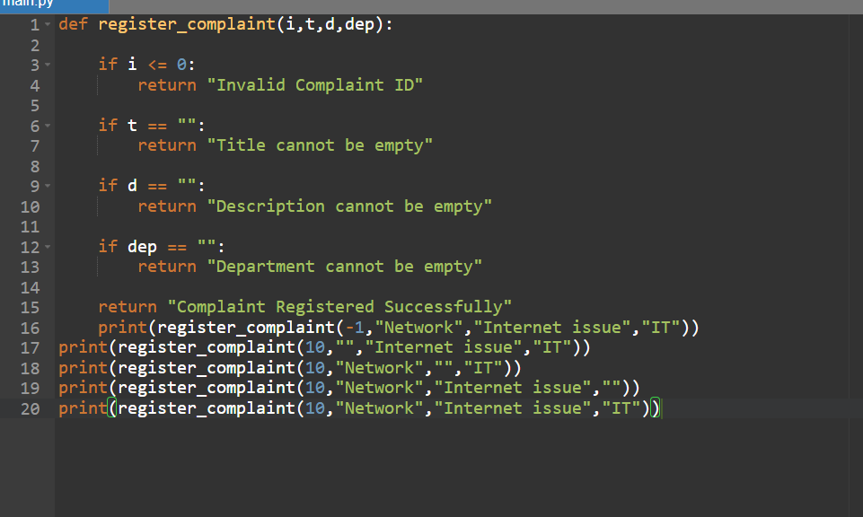

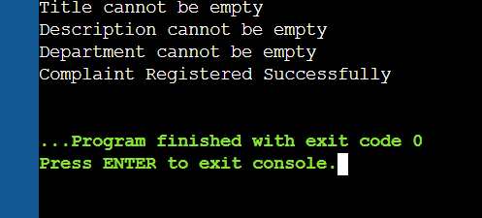

The Output is matched to all the above test cases mentioned in table, then Black Box testing is successful.

7.Conclusion:

- The Complaint Management System's Software Requirement Specification (SRS) document outlines the system's general structure as well as its functional and non-functional requirements.
- Through an orderly and user-friendly platform, the system is designed to make the registration, management, and tracking of complaints easier.
- It makes it simple for users to file complaints, see the details of their complaints, and monitor their progress.
- Using a structured database, the system enables administrators to effectively handle complaints, update complaint status, and keep records.
- This system increases the overall effectiveness of handling complaints and lessens manual labor.
- It also enhances communication and transparency between users and the relevant departments.
- The SRS document serves as a solid basis for the phases of system design, development, and testing.
- The goal of the Complaint Management System is to offer an easy-to-use platform for efficiently handling complaints.
- To improve system performance and usability, future upgrades might include features like enhanced security measures, automated alerts, and a more sophisticated user interface.

8.References:

- Maxim, B. R., and Pressman, R. S. (2020). A Practitioner's Approach to Software Engineering (9th ed.). McGraw-Hill Schools.
- Sommerville ,I.(2016). Software Engineering, 10th ed. Pearson Schooling.
- IEEE Computer Society (2018). IEEE Standard 830 is the IEEE Recommended Practice for Software Requirements Specifications. IEEE.
- The Object Management Group (2017). The specification for the Unified Modeling Language (UML). taken from https://www.omg.org/uml*
- Diagrams.net (2024). Diagram Tool Documentation for Draw.io. taken from https://www.diagrams.net

9.Acknowledgements:

- We would like to sincerely thank the institution and faculty for providing us with the chance to work on the Complaint Management System project.
- Their advice and assistance improved our comprehension of system design and software engineering concepts.
- We also thank our project guide for their insightful recommendations, unwavering support, and helpful criticism throughout the project's development.
- Their advice and assistance enabled us to raise the caliber of our work.

Design Phase

Design Phase:

Description:

- The Complaint Management System's design phase describes the system's architecture and how its various modules work together.
- UML diagrams, which aid in comprehending the connections between various components, are used to describe the system's internal architecture.
- The organization of the system into distinct modules, including the user interface, database components, complaint management module, and authentication module, is the main goal of this phase.
- The design guarantees that every component functions effectively and aids developers in understanding how the system should be implemented.

1.Component Diagram:

Description :

- The Complaint Management System's main software components and their interactions are depicted in the component diagram.
- The system's User Interface component enables users to file complaints, examine complaint information, and monitor the progress of their complaints.
- Before granting users and administrators access to the system, the authentication component confirms their login information.
- While the Admin Module maintains complaint records kept in the system databases and updates complaint status, the Complaint Manager component is in charge of registering, storing, and managing complaints.

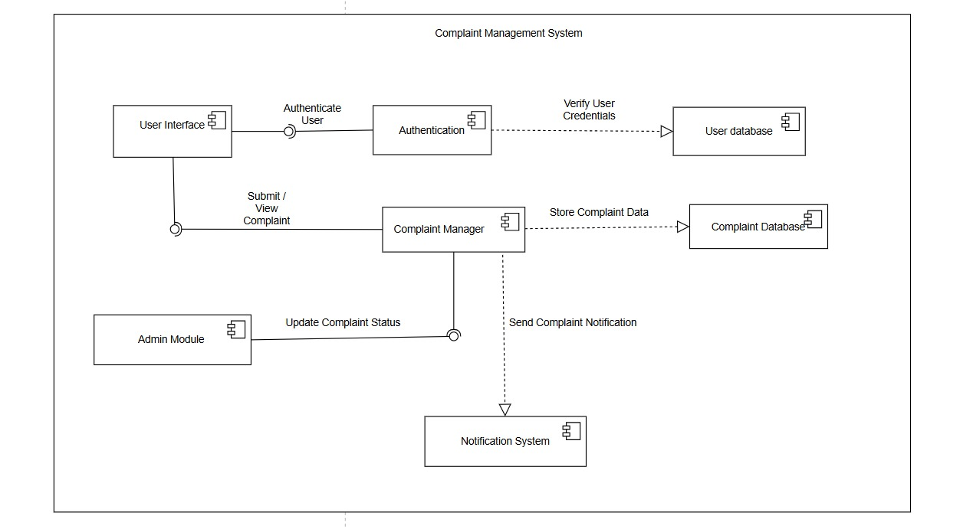
Component Diagram
2.Deployment Diagram:

Description:

- The deployment diagram illustrates the physical configuration of the Complaint Management System and the connections between various hardware nodes.
- Users utilize the client device to access the system via an application interface or web browser.
- User requests for status updates, complaint management, and complaint submission are handled by the application server.
- The database server ensures appropriate information storage and retrieval by storing all system data, including user information and complaint records.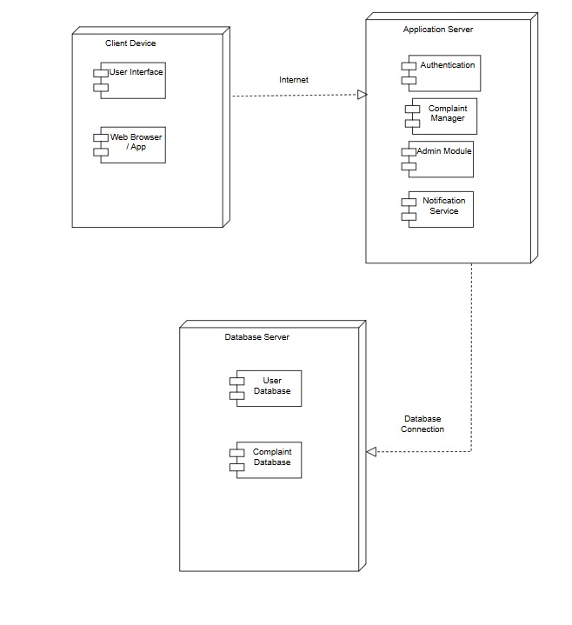
Deployment Diagram

PRODUCT METRICS FORSYSTEMANALYSIS

1.Product Metrics:

Product metrics measure the quality and functionality of the software product. For the Complaint Management System, these metrics help evaluate:

• System functionality
• Complexity
• Maintainability
• Performance

2. Analysis Model Metrics:

Analysis model metrics estimate the size and complexity of the system during requirement analysis.
For the Complaint Management System, the main metrics include:

- External Inputs (EIs): 5

Inputs are data entered by the user.

Examples:

- User registration
- Login details
- Complaint submission
- Complaint update by staff
- Feedback submission

- External Outputs (EOs): 5

Outputs are responses generated by the system.

Examples:

- Complaint confirmation
- Complaint status display
- Resolution notification
- Reports generation
- Alert notifications

- External Inquiries (EQs): 4

User inquiries are requests where users retrieve information without modifying data.

Examples:

- View complaint status
- Track complaint history
- View department details
- View reports

- Internal Logical Files (ILFs): 4

ILFs are data stored and maintained by the system.

Examples:

- User database
- Complaint database
- Department database
- Status records database

- External Interface Files (EIFs): 2

EIFs are data used by the system but maintained by another system.

Examples:

- Email/SMS notification system
- External authentication system

3.Function Point Calculation:

Step 1: Calculate UFP (Unadjusted Function Points)

Component | Count | Weight | Total
External Inputs (EI) | 5 | 4 | 5×4 = 20
External Outputs (EO) | 5 | 5 | 5×5 = 25
External Queries (EQ) | 4 | 4 | 4×4 = 16
Internal Logical Files (ILF) | 4 | 10 | 4×10 = 40
External Interface Files (EIF) | 2 | 7 | 2×7 = 14

Total UFP = 20 + 25 + 16 + 40 + 14 = 115
UFP = 115

4.Complexity Adjustment Factor (CAF):

CAF formula

CAF = 0.65 + (0.01 × ΣFi)

Where,
0.01 is a scaling factor
0.65 is a base adjustment value

• Assume all 14 factors

The Value Adjustment Factors

- Reliable backup and recovery required? – Score: 4 – Complaint data must be securely stored and recoverable.

- Specialized data communication required? – Score: 3 – System communicates with notification services.

- Distributed processing functions present? – Score: 2 – Web system connected with database.

- Is performance critical? – Score: 4 – Fast complaint tracking and updates required.

- Runs in heavily used environment? – Score: 3 – Multiple users access simultaneously.

- Online data entry required? – Score: 5 – Users submit complaints online.

- Multi-screen online data entry required? – Score: 4 – Complaint submission and tracking steps involved.

- ILFs updated online? – Score: 5 – Data updated in real-time.

- Inputs/outputs/files complex? – Score: 3 – Moderate complexity in complaints and reports.

- Internal processing complex? – Score: 4 – Complaint routing and status updates required.

- Code designed for reuse? – Score: 3 – Modules like login and notification reusable.

- Conversion and installation included? – Score: 1 – Minimal installation required.

- Multiple installations required? – Score: 2 – Can be used in multiple institutions.

- Designed for change and ease of use? – Score: 4 – User-friendly and scalable system.

ΣFi = 4+3+2+4+3+5+4+5+3+4+3+1+2+4 = 47

CAF = 0.65 + (0.01 × 47)
CAF = 0.65 + 0.47
CAF = 1.12

5.Final Function Point:

FP = UFP × CAF

FP = 115 × 1.12
FP = 128.8

Therefore,
Function Point (FP) = 128.8

Therefore,
Total Estimated Cost is Rs. 12,88,000

What 128.8 Function Points Means?

- The value 128.8 Function Points represents the functional size of the Complaint Management System after adjusting for system complexity using the Complexity Adjustment Factor (CAF).
- It indicates that the software is a moderately complex system with features such as complaint registration, tracking, status updates, notifications, and admin management.

- Development Effort Estimation

Historically, in software engineering:
1 Function Point = 10 development hours
128.8 × 10 = 1288 hours
Estimated development effort: 1288 hours

Project Duration Based on Number of Developers

Number of Developers | Estimated Effort
1 Developer | 1288 hours
2 Developers | 644 hours
3 Developers | 429 hours
4 Developers | 322 hours

Example:
If 4 developers work 6 hours per day:
322 ÷ 6 = 53.6 ≈ 54 days
Estimated project duration = about 8 weeks

- Productivity Measurement

Developer productivity can be measured as:
Productivity = 128.8 / 1288 = 0.1 FP/hour

- Possible Number of Errors

Industry average:
Errors per Function Point = 0.5 – 1
Estimated errors:
128.8 × 0.7 = 90.16 ≈ 90 errors

- Error Fixing Effort

Assume average time to fix one error = 3 hours
90 × 3 = 270 hours

- Fixing Cost

If developer cost = ₹1000 per hour
270 × 1000 = ₹2,70,000

- Testing Effort

Testing usually requires 30% – 40% of development effort.
Taking average as 35%:
1288 × 0.35 = 450.8 ≈ 451 hours

- Testing Cost

451 × 1000 = ₹4,51,000

- Total Project Cost

Development Cost = ₹12,88,000
Error Fixing Cost = ₹2,70,000
Testing Cost = ₹4,51,000
= 12,88,000 + 2,70,000 + 4,51,000 = ₹20,09,000

- Final Estimated Cost

Total Estimated Project Cost = ₹20,09,000

EMPIRICAL ESTIMATION MODEL
(COCOMO MODEL)

COCOMO MODEL:-

- The COCOMO (Constructive Cost Model) is a standard method used in software engineering to estimate the effort, cost, and schedule required for a software project.
- Introduced by Barry Boehm in 1981, it relies on historical data and mathematical formulas to predict project outcomes based primarily on the size of the software.

There are 2 Types of Models:-

- Basic COCOMO Model
- Intermediate COCOMO Model

1. Basic COCOMO Model:-

- The Basic COCOMO can be used for quick and slightly rough calculations of software costs.
- The following formulas are used to calculate effort and time estimates:

- Effort (E) = A × (KLOC)^B

- Time (T) = C × (Effort)^D

- Persons required = Effort / Time

The constant values A, B, C and D for different categories of software projects:-

Software Project | A | B | C | D
Organic | 2.4 | 1.05 | 2.5 | 0.38
Semi Detached | 3.0 | 1.12 | 2.5 | 0.35
Embedded | 3.6 | 1.20 | 2.5 | 0.32

Project Details:-

The Complaint Management System is a Small Organic Project, with a size of 10 KLOC.
A = 2.4
B = 1.05
C = 2.5
D = 0.38

Effort Calculation:-

Effort = 2.4 × (10)^1.05
= 2.4 × 11.22
≈ 26.93 person-months

Time Calculation:-

Time = 2.5 × (26.93)^0.38
≈ 2.5 × 3.50
≈ 8.75 months

Team Size:-

Persons required = 26.93 / 8.75
≈ 3.08 ≈ 3 persons

Basic COCOMO Result of Complaint Management System:
- KLOC = 10
- Effort = 26.93 PM
- Time = 8.75 months
- Team size = 3 persons
2. Intermediate COCOMO Model:-

- The Intermediate COCOMO model estimates software effort by considering both size (KLOC) and cost drivers. It uses an Effort Adjustment Factor (EAF) to account for factors like product complexity, team capability, and tools.
- In this model, factors such as reliability, experience, and capability are considered along with LOC.
- These factors are called Cost Drivers and 15 such drivers are used.

Product attributes:-

1. Required software reliability
Complaint data should be accurate and secure, so reliability is important.
Rating: High = 1.15

2. Size of application database
Database is moderate (users, complaints, departments).
Rating: Nominal = 1.00

3. Product complexity
Includes login, complaint handling, tracking, notification, and reporting.
Rating: High = 1.15

Hardware attributes:-

4. Run-time performance constraints
No strict real-time requirement.
Rating: Nominal = 1.00

5. Memory constraints
No serious memory limitations.
Rating: Nominal = 1.00

6. Volatility of virtual machine environment
Stable development environment.
Rating: Nominal = 1.00

7. Required turnaround time
No urgent processing requirement.
Rating: Nominal = 1.00

Personnel attributes:-

8. Analyst capability
Average capability assumed.
Rating: Nominal = 1.00

9. Software engineering capability
Standard student-level team.
Rating: Nominal = 1.00

10. Application experience
Moderate experience in this type of system.
Rating: Low = 1.17

11. Virtual machine experience
Normal experience assumed.
Rating: Nominal = 1.00

12. Programming language experience
Using familiar languages like Java.
Rating: Nominal = 1.00

Project attributes:-

13. Use of software tools
Using IDEs, DB tools, UML tools.
Rating: High = 0.91

14. Application of software engineering methods
Proper use of SRS, UML, testing, design.
Rating: High = 0.91

15. Required development schedule
No strict deadline pressure.
Rating: Nominal = 1.00

Tabular representation:-

Cost Drivers | Very Low | Low | Nominal | High | Very High | Extra High
1 |  |  |  | 1.15
2 |  |  | 1.00
3 |  |  |  | 1.15
4 |  |  | 1.00
5 |  |  | 1.00
6 |  |  | 1.00
7 |  |  | 1.00
8 |  |  | 1.00
9 |  |  | 1.00
10 |  | 1.17
11 |  |  | 1.00
12 |  |  | 1.00
13 |  |  |  | 0.91
14 |  |  |  | 0.91
15 |  |  | 1.00

EAF Calculation:-

EAF = Product of cost drivers
EAF = 1.15 × 1.00 × 1.15 × 1.00 × 1.00 × 1.00 × 1.00 × 1.00 × 1.00 × 1.17 × 1.00 × 1.00 × 0.91 × 0.91 × 1.00
EAF ≈ 1.28

The following formulas are used to calculate effort and time estimates:

- Effort (E) = A × (KLOC)^B

- Time (T) = C × (Effort)^D

- Persons required = Effort / Time

The Complaint Management System is a Small Organic Project, with a size of 10 KLOC.
A = 2.4
B = 1.05
C = 2.5
D = 0.38

Effort Calculation:-

Effort = 2.4 × (10)^1.05 × 1.28
≈ 46.01 person-months

Development Time :-

Time = 2.5 × (46.01)^0.38
≈ 10.71 months

Team Size:-

Persons required = 46.01 / 10.71
≈ 4.30 ≈ 4 persons

Final Result(Intermediate COCOMO)

• Effort = 46.01 PM
•Development Time = 10.71 months
• Team size = 4 persons

